Name: _____________________________ January 10, 2018
Kobrin/Losquadro Math 8
Unit 6 Quiz Review

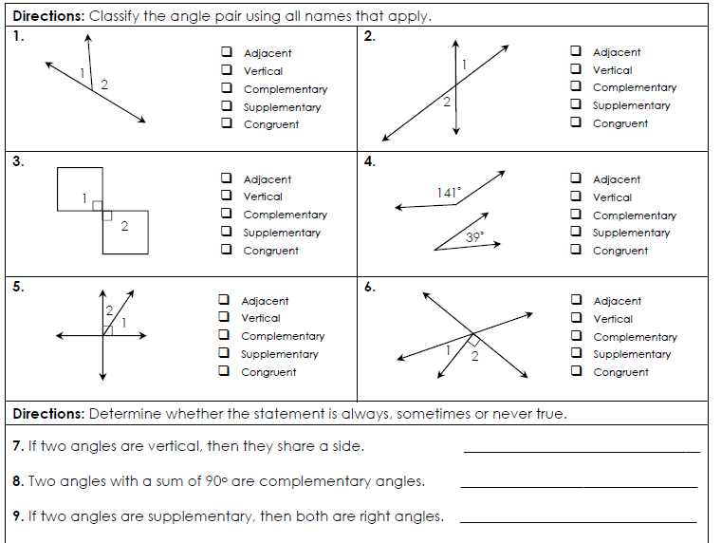

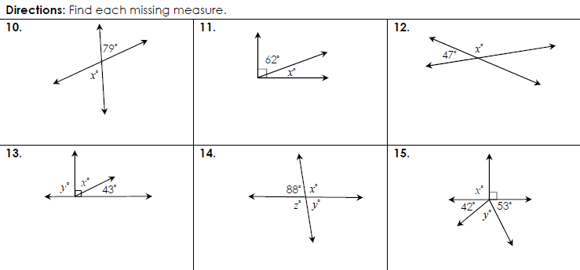

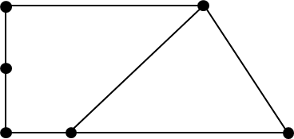
Use the diagram below classify each angle as acute, obtuse, right, or straight.
16. m∠EDB Classify: _____________________
17. m ∠FED Classify: _____________________
18. m∠BCD Classify: _____________________
19. m∠AFE Classify: _____________________
C
A
B
D
E
F

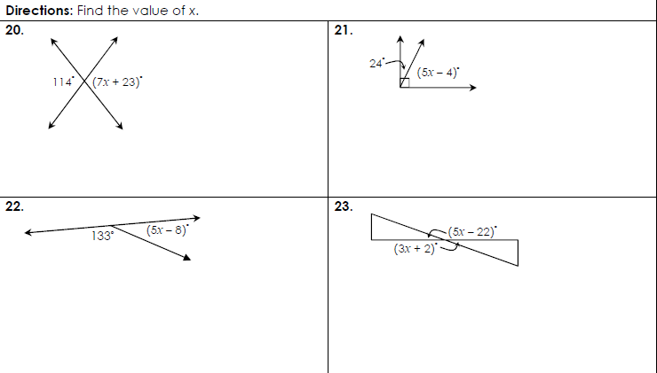

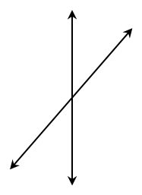
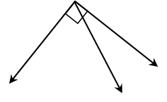
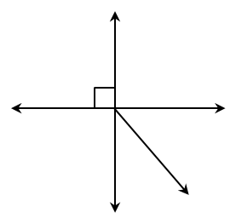
Solve for x. Then find the measure of each angle in the diagram. (Diagrams are not drawn to scale)
24.
25.
26.
27.
127°
(9x – 19)°
(2x – 3)°
67°
(5x + 44)°
(8x – 13)°
(7x + 1)°
(13x – 11)°

28. If ∠1 and ∠2 are complementary and their measures are in the ratio of 2:3. Find the ∠1 & m∠2.

29. ∠E and ∠F are vertical angles. If m∠E = (5x + 55)° and m∠F = (11x – 53)°, find m∠E.

30. ∠Q and ∠R are complementary angles. If m∠Q = (31 – 3x)° and m∠R = (19x – 5)°, find m∠R.

31. ∠V and ∠W are supplementary angles. If m∠V is two degrees less than six times the measure of ∠W, find the measure of each angle.

32. ∠A and ∠B are complementary angles. If m∠B is fourteen degrees more than the measure of ∠A, find the measure of each angle.

