Name: ____________________________________ December 19, 2017
CC Algebra

Unit 5 Functions Test Review

1. Given f(x) = 7x + 8 and g(x) = –9x – 4, find h(x) = f(x) – g(x).

- h(x) = -2x + 4 C. h(x) = -2x - 4
- h(x) = 16x + 12 D. h(x) = 16x + 4

2. Which statement is true about the relation shown on the graph below?
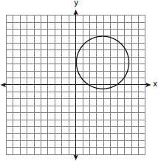
A. | It is a function because there exists one x-coordinate for each y-coordinate.
B. | It is a function because there exists one y-coordinate for each x-coordinate.
C. | It is not a function because there are multiple y-values for a given x-value.
D. | It is not a function because there are multiple x-values for a given y-value.

3. The function C(t) gives the cost C of buying t tickets to a museum exhibit when a group discount is
offered.

Which statement describes what C(10) represents?

- 10 tickets cost $200 C. 10 tickets cost $20
- 10 tickets cost $180 D. 10 tickets cost $18

4. A ball is thrown into the air from the edge of a 48-foot-high cliff so that it eventually lands on the
ground. The graph below shows the height, y, of the ball from the ground after x seconds.
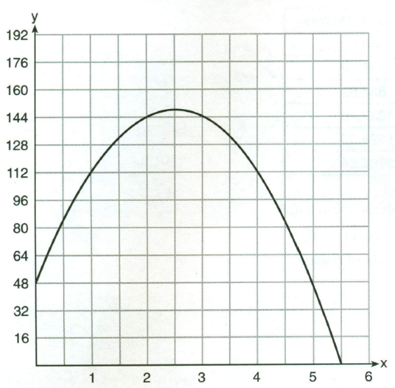

For which interval is the balls’ height always increasing?

A. 0 < x < 2.5 C. 2.5 < x < 5.5
B. 0 < x < 5.5 D. x > 2

- If a function is defined by $f\left(x\right)= x^{2}-3$, then which of the following is the value of f(8)?

- 13 C. 67
- 61 D. 7

- What is the average rate of change between x = 1 and x = 4 when f(x) = x² + 5 ?
A. 5 B. 9 C. 3 D. 15

- If , for what value of x does?
A. 1 B. -1 C. 18 D. -2

- The graph below represents a jogger’s speed during her 20 minute jog around her neighborhood
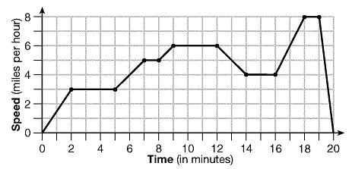

Which of the following statements best describes what the jogger was doing during the 9-12 minute interval of her jog?
- She was jogging at a constant rate.
- She was standing still.
- She was increasing her speed.
- She was decreasing her speed.

- Which of the following is a function?
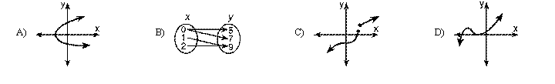

- If f(x) = 3x – 1 and g(x) = 2f(x) + 4 find g(-2)
A. -14 C. -10
B. -7 D. 10

- What is the range of the function f(x) = 5 – 8x when the domain is {-2, 2, 4}?
A. {-27, -11} C. {-27, -11, 21}
B. {-2, 2, 4} D. {1/8, 3/8, 7/8}

- Which set of ordered pairs does not represent a function?
A.
B.
C.
D
The table below shows the average diameter of a pupil in a person’s eye as he or she grows older.
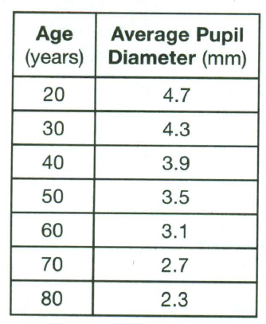

- What is the average rate of change, in millimeters per year, of a person’s pupil diameter form age 20 to age 80?
A. 2.4 B. 0.04 C. -2.4 D. -0.04

- The Jamison family kept a log of the distance they traveled during a trip, as represented by the graph below.

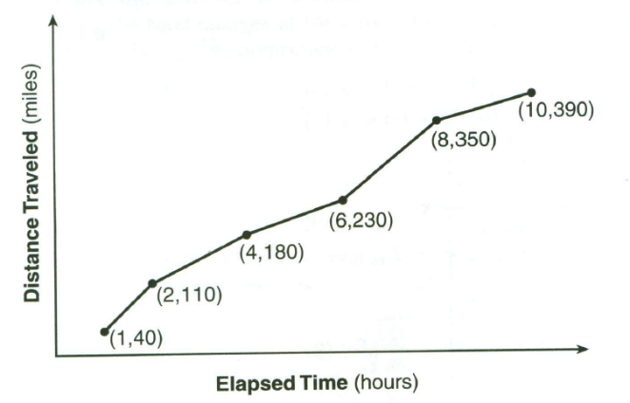

During which interval was their average speed the greatest?

A. the first hour to the second hour C. the sixth hour to the eighth hour
B. the second hour to the fourth hour D. the eighth hour to the tenth hour

- Given f(x) = x + 5 and g(x) = 4x + 4, find h(x) = f(x) – g(x)

- Given the relation f(x) = 3x – 5, g(x) = -2x + 8, h(x) = f(x) + g(x) find the following:

  - $h\left(2\right)=$ b.) h(-1) =

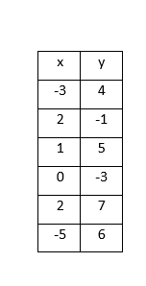
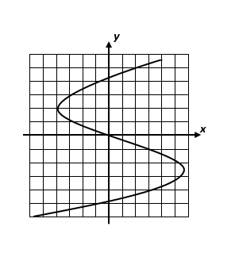
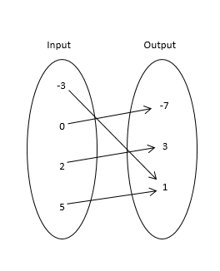
17. Which one of the following relations is a function, A, B, or C? Explain your reasoning.
A B C

18. Given the function $f\left(x\right)$ $=\frac{2}{3}x-5$
A. Find $f\left(9\right) and f(-6)$ B. Find the input where $f\left(x\right)=-15$

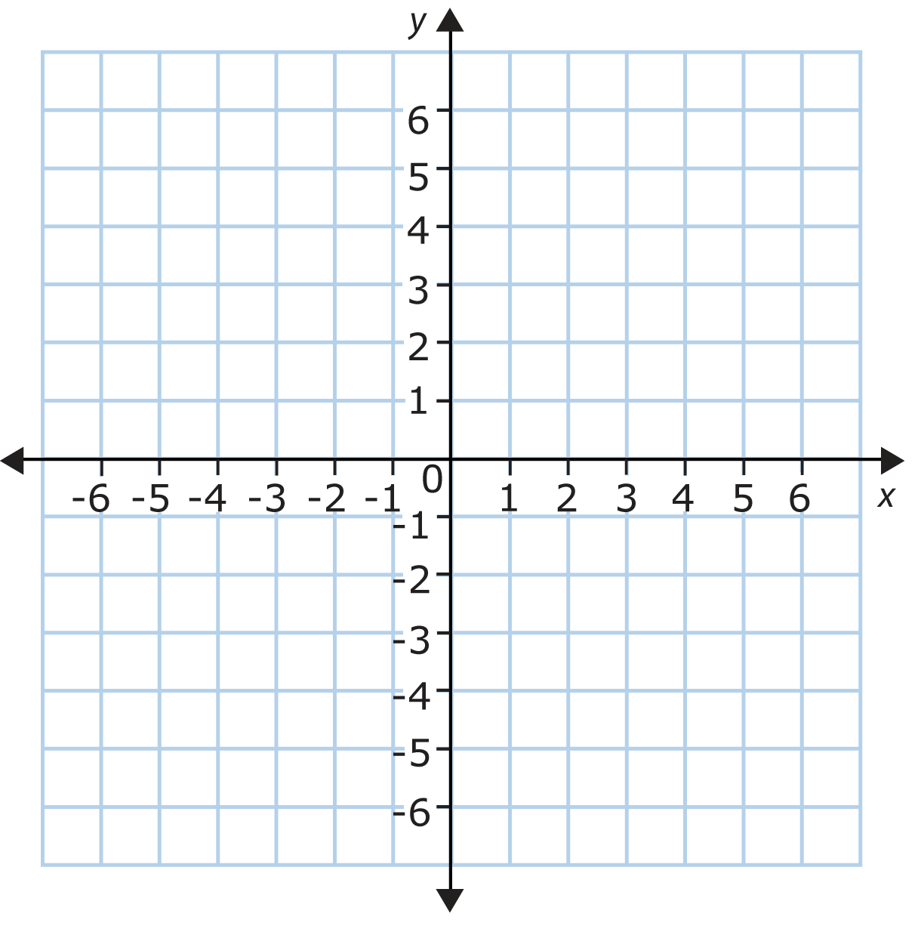
19. Graph the following piecewise function

$$f\left(x\right)= \left\{\begin{aligned}x+4;x≤-3 \\ 4; -3<x≤2 \\ 5-x;x>2\end{aligned}\right.$$

20. Use the relation {(-2, 2), (1, 4), (0, -1), (1, -6), (4, -1)}
  - State the domain and range.
D = ___________________ R = ___________________

  - Create a mapping diagram

  - Is it a function? Explain why or why not

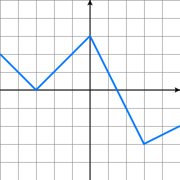
21. The function $y=f(x)$ is defined by the graph below.

A. Find $f(-5)$___________ Find $f(0)$ __________

B. State the zeros of the function.

C. Find all x-values such that $f\left(x\right)=1$

D. What is the y-intercept of the function? ___________

E. Find the coordinates $(x,y)$ for the absolute maximum and minimum values.

Maximum _______________ Minimum ________________

F. Over what two intervals is the function decreasing?

_______________________ and ________________________

G. Is the function positive or negative over the interval $-4<x<1.5$ ? ________________________

H. State one interval where the function is negative ______________________________

- B
- C
- B
- A
- B
- A
- B
- A
- D
- C
- C
- B
- D
- A

- –3x + 1

- a. h(2) = 5
b. h(-1) = 2

- A, no repeating x-values

- a. f(9) = 1 & f(-6) = -9
b. x = -15

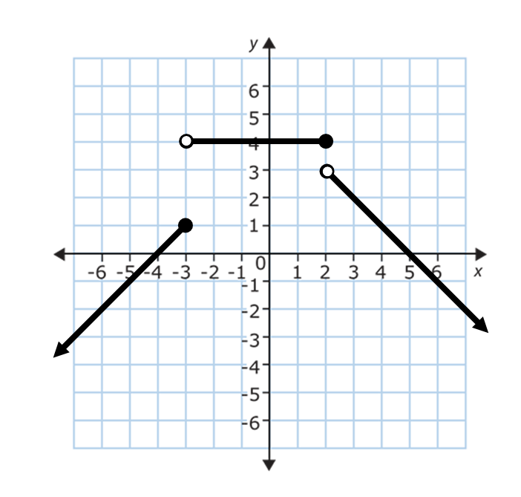

- D = {-2, 0, 1, 4}
R = {-6, -1, 2, 4}
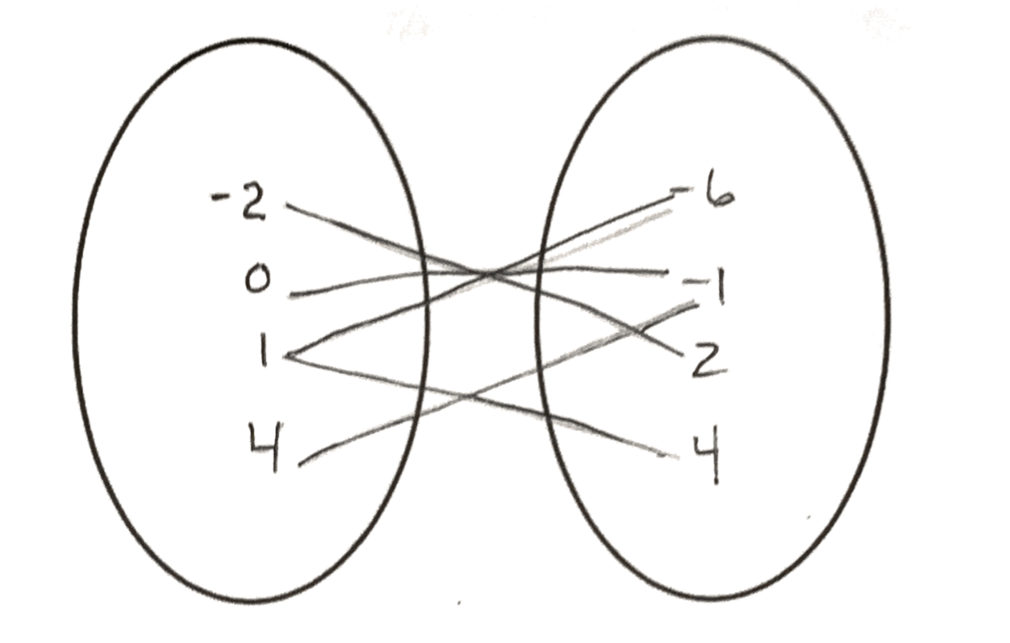
Not a function

- a. f(-5) = 1
f(0) = 3
b. x = -3, $1\frac{1}{2}$
c. x = -4, -1, 1
d. y = 3
e. Max (0, 3)
Min (3, -3)
f. (-5, -3) and (0, 3)
g. Positive
h. ($1\frac{1}{2},5)$

