Name________________ Date______________
Math 8

Finding Slope from a Graph Homework

Find the follow slopes from the Graphs:
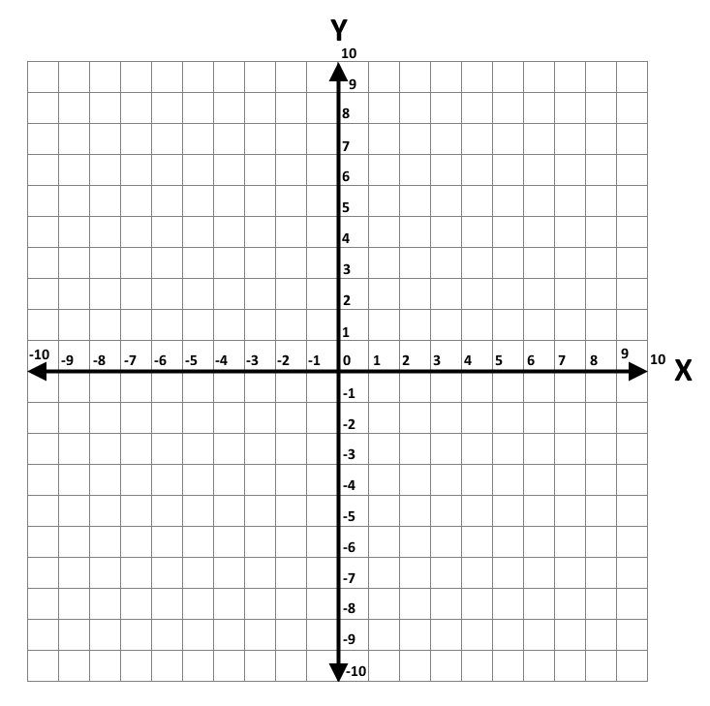
- 2)

Slope = ____________ Slope = ___________

- 4)

Slope = ____________ Slope = ___________
Plot the following points and find the slope of the line:

5) (-4, 0) and (-2,5)

Slope = _______________

6) (7,0) and (5,-4)

Slope = ________________

