Name_____________ Date________
Math 8
Finding X and Y Intercepts Algebraically Homework

Find the x and y intercepts of the following equations

- 3y + 2x = -24

- 6x – 9y = 36

- x + y = 6

- 4x – 3y = 1

- 40 = 8y + 5x

- Find the x and y intercepts
- Plot the points on the graph
- Connect the points to make a line

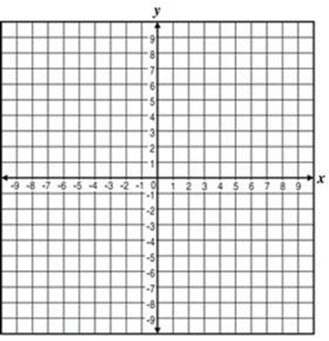
- 8 = 2x – y

