**Name: ______________________________________ Date:________________**

**Kobrin/Losquadro Math 8**

**Systems of Equations Final Review 6**

1. Which step can be taken to eliminate a variable from the linear system below?

-4x + 2y = -2

4x – 3y = -1

1. Add to eliminate variable x
2. Subtract to eliminate the variable x
3. Add to eliminate the variable y
4. Subtract to eliminate the variable y

**2.** What point is the intersection of the graphs of the lines *y* = -x + 7 and *y* = x + 3?

1. (3,4) (c) (2,5)
2. (-2,1) (d) (0, 0)

**3.** On one day, 4 gardeners and 4 helpers earned $360. On another day, the same number of hours and the same rate of pay, 5 gardeners and 6 helpers earned $480. How much does a gardener and a helper earn each day?

(a) 4x + 4y = 480 (c) 4x + 4y = 360

5x + 6y = 360 5x + 6y = 480

(b) 4x + 6y = 480 (d) 4x + 6y = 360

5x + 4x = 360 5x + 4x = 480

**4.** Which ordered pair is the solution to the system of equations?

3*x* + *y* = 10

2*x* – *y* = 5

1. (1,3) **(c)** (–5, 5)
2. (3, –5) **(d)** (3,1)

**5.** Frank wants to eliminate the variable *y* from the system by adding.

7*x* – 6*y* = 8

2*x* + 2*y* = 6

First, he will have to multiply one of the equations by a number. Which step will enable him to eliminate *y* by using the elimination method?

1. multiply each term in 7*x* – 6*y* = 8 by 3
2. multiply each term in 7*x* – 6*y* = 8 by –3
3. multiply each term in 2*x* + 2*y* = 6 by 3
4. multiply each term in 2*x* + 2*y* = 6 by –3

**6.** What does the graph of a system of equations look like when there are **no solutions**?

**(a)** intersecting lines **(c)** the same line

**(b)** parallel lines **(d)** it is not possible

**7.** You are purchasing paint and paintbrushes for an art project. Tubes of paint cost $6 each and paintbrushes cost $8 each. You plan on spending $60 and purchasing a total of 9 items. Which linear system best represents the situation?

**(a)** 6*x* + 8*y* = 9 **(c)** 9*x* + 9*y* = 60

*x* + *y* = 60 6*x* + 8*y* = 60

**(b)** 6*x* + 9*y* = 60 **(d)** *x* + *y* = 9

9*x* + 8*y* = 60 6*x* + 8*y* = 60

Solve the following systems of equations graphically.

8) 3x + y = -10 9) y = - 2x + 3 10) x + 2y = 6

y = 2x + 5 y = -2x – 4 -2x + y = 8





So

S

Solve using the substitution method and check.

11) y = 2x – 1 12) 3x + 2y = 20

2x + y = 3 x – y = -5

Solve using the elimination method and check.

13) 3x – y = 30 14) 2x – 9y = 15

-3x + 7y = 6 -x + 3y = -6

Solve each of the following problems. Make sure to set up appropriate equations and SHOW ALL WORK!

15) The sum of two number is 36. Twice the first number minus the second is 6. Find the numbers.

16) Mike decides to open up his own fast food restaurant titled “Mike’s Burgers”. Mike’s Burgers sells three hamburgers and two milkshakes for $3.35. Two hamburgers and two milkshakes cost $2.60. Find the cost of each item.

**Answer Key**

1. A
2. 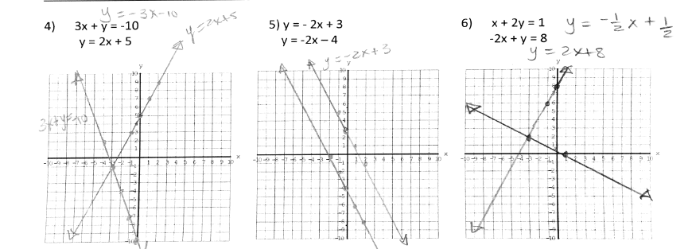C
3. C
4. (-3, -1)
5. No Solution
6. (-3, 2)
7. (1, 1)
8. (2, 7)
9. (12, 6)
10. (3, -1)
11. 14

22

1. Hamburger $0.75

Milk Shake $0.55