Name: ______________________________________ Date: _________________________
Kobrin/ Losquadro Math 8
Writing Linear Equations Final Review 5
- What is an equation of the linear function that is represented by the following table of values? 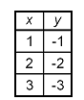

  - y = 1 – x
  - y = x – 1
  - y = -x
  - y = x

- What is an equation of the linear function that is represented by the following table of values? 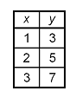

  - y = x + 2
  - y = x + 3
  - y = x – 2
  - y = 2x + 1

- What is the equation of the line having a slope of 0 and passing through the point (-4, -2)?

  - x = -4
  - y = -2
  - y = -4
  - x = -2

- What is the equation of the line having no slope and passing through the point (6,8)?

  - y = 6
  - y = 8
  - x = 6
  - x = 8

- What is an equation of the linear function whose graph passes through the points (3, 17) and (7, 25)?

  - y = 2x + 11
  - y = 2x – 11
  - y = -3x + 26
  - y = -2x + 23

- What is an equation of the linear function whose graph passes through the points (-10, 6) and (15, -14)?

  - $y=-\frac{5}{4}x-2$
  - $y=-\frac{4}{5}x-2$
  - $y=\frac{4}{5}x-2$
  - $y=-2x-\frac{4}{5}$

- What is the equation of the line having a slope of $\frac{1}{3}$ and passing through the point (6, -5)?

  - $y=\frac{1}{3}x+6$
  - $y= \frac{1}{3}x+7$
  - $y=\frac{1}{3}x-7$
  - $y= \frac{1}{3}x-5$

- What is the equation of the line that passes through the points (-4, 2) and (-4, 6)?

  - x = 2
  - y = 2
  - x = -4
  - y = -4

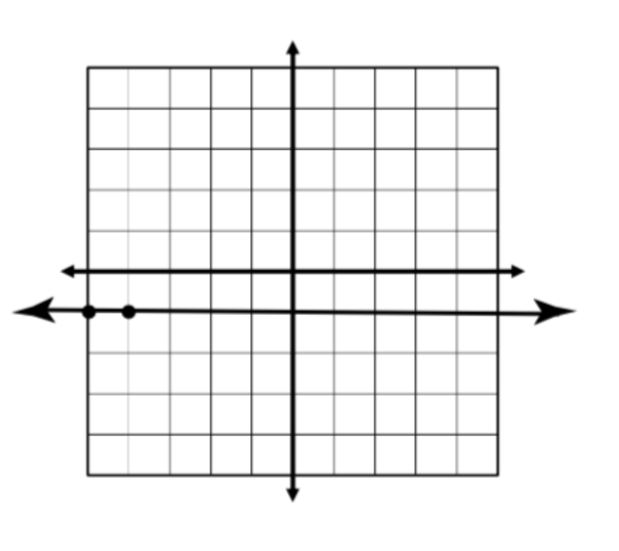
- What is the equation of the line graphed?

  - $y= 1$
  - $y= -1$
  - $x=1$
  - $x= -1$

- What is the equation of the line graphed?
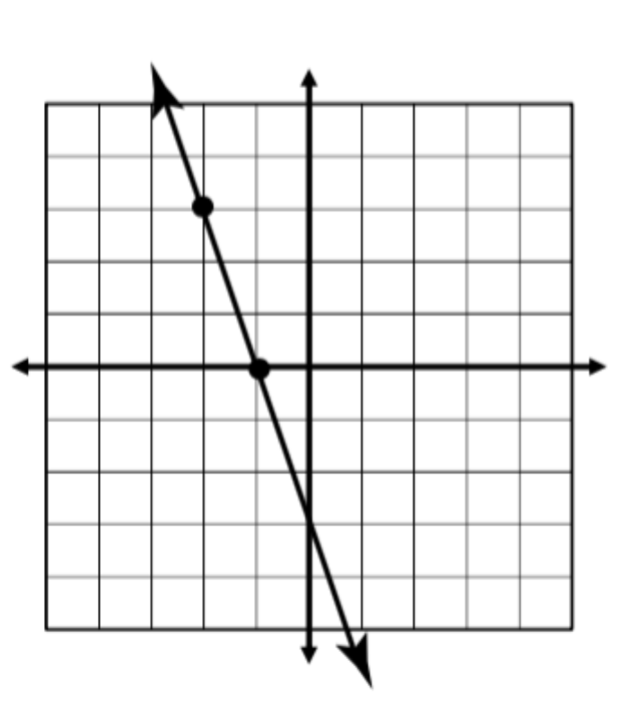

  - y = 3x – 3
  - y = -3x – 3
  - $y=\frac{1}{3}x-3$
  - $y=-\frac{1}{3}x-3$

- Write the equation of the line that passes through the points (-3, -4) and (12, -9).

- Write the equation of the line that has a slope of $-\frac{1}{2}$ and passes through the point (-4, -6).

- Write the equation of a linear function that is represented by the following table of values.
X | Y
6 | -2
3 | 0
-3 | 4

- Write the equation of the line graphed below.
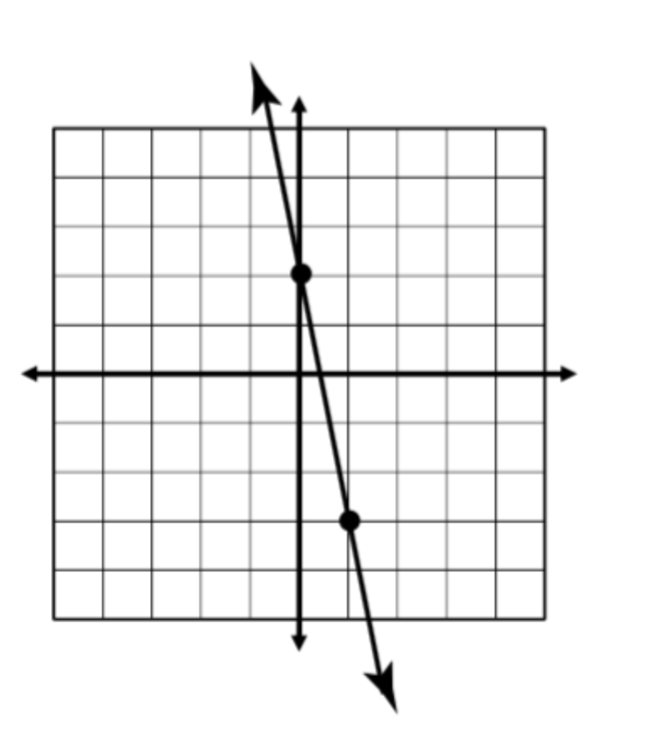
- Write the equation of the line graphed below.
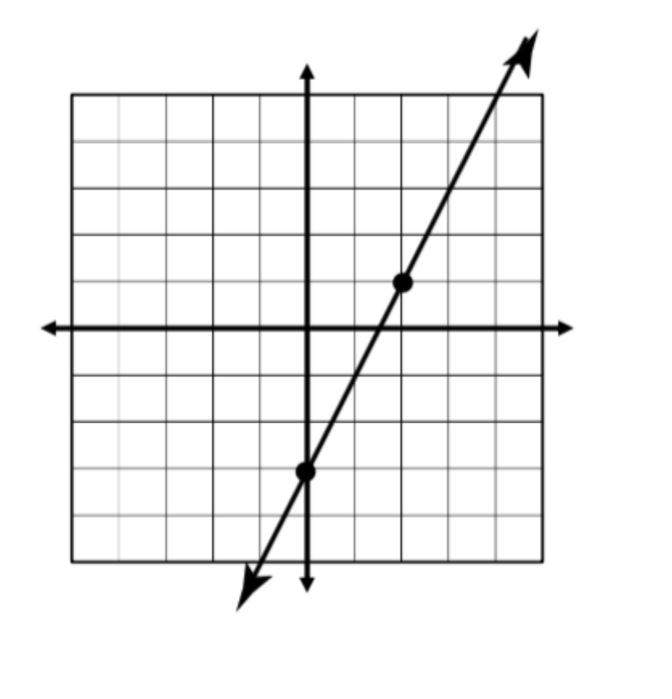

- You and your friends plan to attend the county fair this weekend. The admission to the fair is $5 and the cost per ride is $0.50.
  - Write an equation to represent the number of rides you can go on.

  - If your parents gave you $20, how many rides can you go on?

