Name: _________________________________ May 29, 2018

Kobrin/Losquadro Math 8

**Final Exam Review # 4 – Angles**

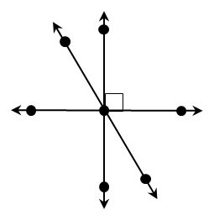

**1. Which of the following describes ∠*JNL* and   
 ∠*MNK*? Check all that apply.**

Vertical

Adjacent

Complementary

Supplementary

Congruent

**3. If ∠*A* is complementary to ∠*B*, ∠*B* is   
 supplementary to ∠*C*, and *m*∠*A* = 59°,   
 find *m*∠*C.***

**A.** 31° **C.** 121°

**B.** 109° **D.** 149°

*P*

*J*

*L*

*M*

*N*

**4.** Which statement is always true?

**A.** Two right angles are complementary.

**B.** Given two vertical in which one is acute,  
 the other must be obtuse.  
  
  
  
  
  
  
  
**C.** If two angles are complementary, then   
 they are both acute.

**D.** If two angles are supplementary,   
 then they are adjacent.

*Q*

*K*

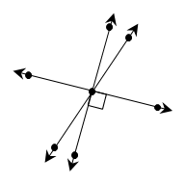

*C*

**2. Given the diagram to the right,   
 which statements are true?   
 Check all that apply.**



*D*

*F*

*H*

*B*

*E*

*G*

∠*DHF* and ∠*GHE* are vertical  
 and complementary angles.

∠*BHD* and ∠*EHC* are vertical  
 and supplementary angles.

∠*BHG* and ∠*GHE* are adjacent  
 and complementary angles.

∠*FHC* and ∠*EHC* are adjacent  
 and congruent angles.

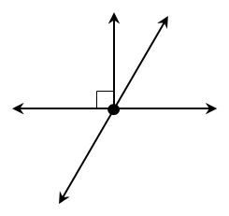

**5. Find the value of *x*.**

**A.** 3.5

**B.** 6

**C.** 8

**D.** 12.5

(9*x* – 4)°

(5*x* + 10)°

**8.** Given: *m*∠1 = 28°; *m*∠2 = 62°

* Vertical
* Adjacent
* Complementary
* Supplementary

1

2

**6.** If *m*∠*P* = (19*x* – 5)° and *x* = 4, find *m*∠*P* and classify the angle.

* Acute
* Right
* Obtuse
* Straight

**.**

**9.** If *m*∠A= (11*x* + 37)° and *x* = 13, find *m*∠Aand classify the angle.

*m*∠A=

* Acute
* Right
* Obtuse
* Straight

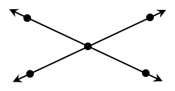

**7. Find *m*∠*STQ.***

(7*x* + 23)°

(9*x* – 7)°

**A.** 52°

**B.** 64°

**C.** 116°

**D.** 128°

**10.** If ∠*R* and ∠*S* are supplementary angles and *m*∠*R* = 39°, find *m*∠*S*.

**11.** If ∠1 and ∠2 are vertical angles and *m*∠2 = 108°, find *m*∠1.

**12.** If ∠*C* and ∠*D* are complementary angles, *mC* = (4*x* + 3)°, and *m*∠*D* = (15*x* – 8)°, find *m*∠*D*.

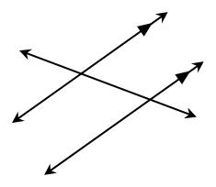

**14.** ∠2 and ∠5

**15.** ∠4 and ∠5

**16.** ∠3 and ∠5

**Using the diagram below, classify each angle pair as corresponding, alternate interior, alternate exterior, or consecutive interior.**

**13.** ∠1 and ∠6 __________________________________________

*n*

*r*

*m*

4

3

5

2

1

6

8

7

**17.** Using the diagram above, if *m*∠2 = 107°, find each angle measure.

*m*∠1 =

*m*∠3 =

*m*∠6 =

*m*∠7 =

*m*∠4 =

*m*∠5 =

*m*∠8 =

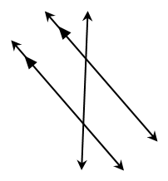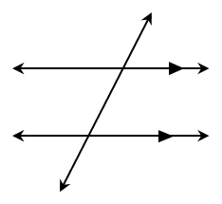

**For questions 18 and 19, find the value of *x*.**

**18.**

**19.**

(13*x* + 12)°

129°

(7*x* + 10)°

(11*x* – 6)°

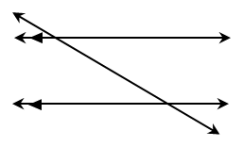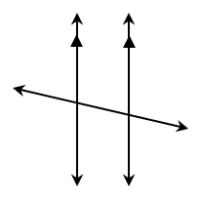

**21.**

**For questions 20 and 21, find *m*∠1.**

**20.**

(8*x* – 32)°

(6*x* + 2)°

1

(2*x* – 3)°

1

(9*x* + 7)°

22. Find the value of x 23. Find the value of x



24. Find the value of x 25. Find the value of x

