**Name: __________________________________ Date: ____________**

**Kobrin/Losquadro Math 8**

**Graphing Linear Equations Final Review 2**

1. What is the slope of the line joining (10, 6) and (30, 10)?
2. 
3. 5
4. 
5. -5
6. What is the slope of the line whose equation is 2y = 5x + 4?
   1. 2
   2. 5
   3. 
   4. 
7. Which of the following sets of ordered pairs are all solutions to the equation 2y + x = 2?
   1. (-10, 6), (2, 0), (-18, -8)
   2. (-10, -6), (2, 0), (18, -8)
   3. (-10, 6), (2, 0), (18, -8)
   4. (-10, 6), (-2, 0), (18, -8)
8. What is the slope of line l?

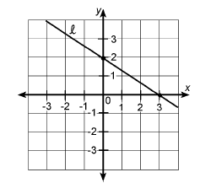

* + 1. 
    2. 
    3. 
    4. 

1. What is the slope of the line joining (2, -3) and (-4, -3)?
2. 
3. 0
4. No slope
5. 
6. What is the slope of the line that passes through the points (-3,7) and (-9,4)?
   1. 
   2. 
   3. 
   4. 2
7. Which one of the following points is a solution to the equation 2x + 3y = 8?

a. (-1,3) c. (2,2)

b. (-2,4) d. (1,4)

1. Which equation represents a line parallel to the *x*-axis?
   1. *y* = −5
   2. *y* = −5*x*
   3. x = 3
   4. x = 3y
2. What is an equation of the line that passes through the point (0,−4)

and has a slope of 2?

a. *y* = -2*x* + 4

b. *y* = -2*x* − 4

c. y = 2*x* – 4

d. y = 2x + 4

1. Which graph shows the equation y = x + 4?

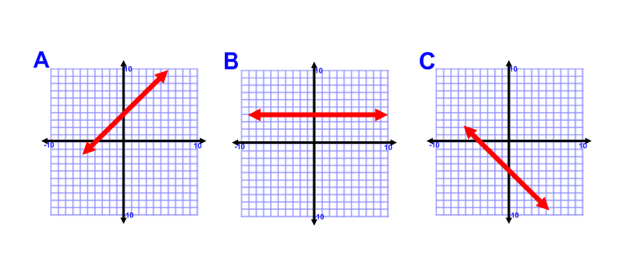

1. Determine which point is a solution to the linear function –x + 3y = 12
   1. (-8, 2)
   2. (-2, 5)
   3. (0, 4)
   4. (5, -1)
2. The line x = 5 is:
   1. Horizontal
   2. Vertical
   3. Neither
   4. Cannot be determined
3. What is the slope of the line whose equation is x + 2y = 6?
   1. 1
   2. 2
   3. 6
$-\frac{1}{2}$

4. What is the x – intercept of the line 5x + 4y = 40?
   1. 10
   2. 8
   3. 4
   4. 5

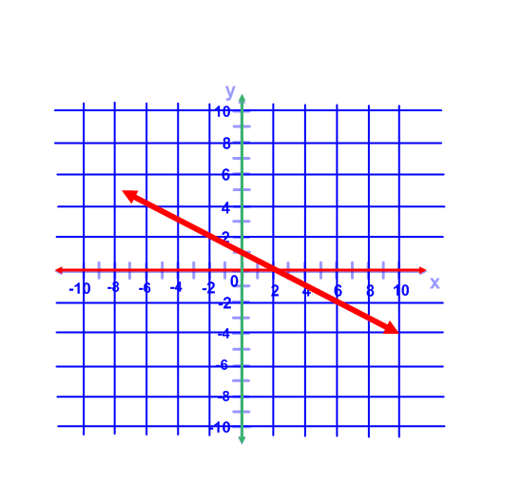

1. What is the y intercept of the line?
   1. 0
   2. 1
   3. 2
   4. 4
2. The table below represents which equation?

|  |  |  |  |  |
| --- | --- | --- | --- | --- |
| x | -1 | 0 | 1 | 2 |
| y | -10 | -6 | -2 | 2 |

1. y = -x – 10
2. y = -6x
3. y = 4x – 6
4. y = -4x + 2
5. Determine the y-intercept of the line graphed below.
6. 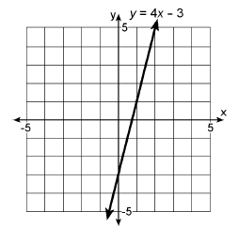-3
7. 3
8. -4
9. 4
10. Which of the following represents the graph of the equation y = -3?

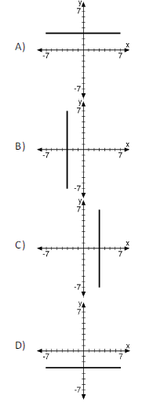

1. Find the x - intercept and the y – intercept of the following equation without graphing. 4x + y = 8
2. 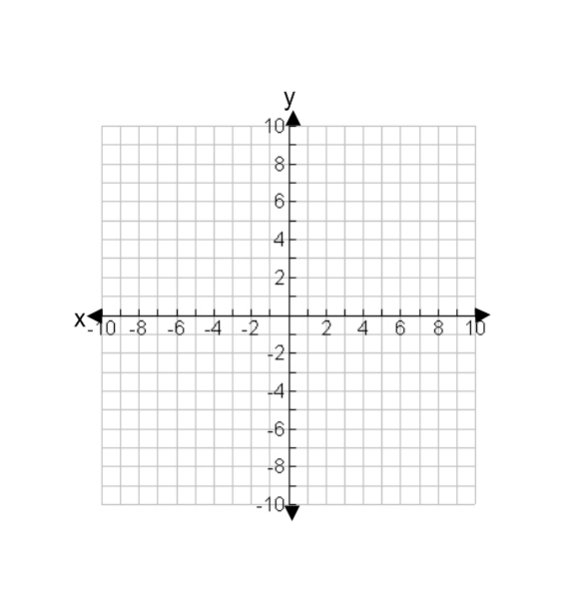Graph the following equation using a table of values y = -2x – 1
3. Graph the equation using slope intercept form y = x + 3
4. Graph the following equation x = 3



1. Identify the slope and the y-intercept and then graph the equation 4x = 3y + 6
2. Identify the slope and the y-intercept and then graph the equation 5x = 2y – 8





1. Identify the slope and the y-intercept and then graph the equation 5 – 5y = 4x

Answers

* 1. C
  2. D
  3. C
  4. A
  5. B
  6. D
  7. A
  8. C
  9. X-intercept = 2

y-intercept = 8

* 1. 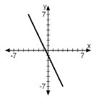
  2. 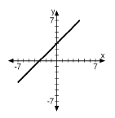
  3. 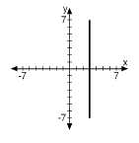
  4. 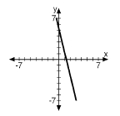

m = 

b = -2

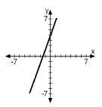

* 1. 

m = 

b = 4

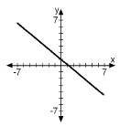

* 1. 

m = 

b = 1