Name: _____________________________ Date: ______________

Teacher: ___________________________ Math 8
Cumulative Review # 2.7
Show work for all questions for full credit
& write your answers on the lines provided!!!
(If you feel no work is needed you must explain your reasoning)

1. | Which ordered pair is NOT a solution to 2x + 3y = 12?
 | A. | (0, 4)
 | B. | (3, 2)
 | C. | (2, 3)
 | D. | (6, 0)

1 ._________________________

2. | Simplify 4n + 2(3n – 5) – 8 + n
 | A. | 8n – 13
 | B. | 9n – 8
 | C. | 10n – 2
 | D. | 11n – 18
2 ._________________________

3. | Joseph bought a new skateboard from a catalog. The price of the kit was $124.95. The state sales tax of 7% was added, and then a $15 charge for shipping was added after the sales tax. What wad the total amount Joseph paid, including tax and shipping?

3 ._________________________

4. | Shelly bought 2 packages of paper for $5.80 each and 4 notebooks. She spent a total of $32 for the packages of paper and the notebooks. Write and solve an equation to find the cost of 1 notebook.

4 ._________________________

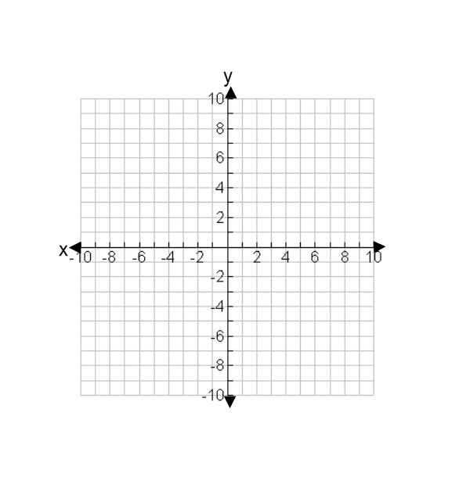  5. | Solve graphically the system of equations
y + 2x = 3
y = 2x – 1

5 . (_____, _____)

