Name: ______________________________ Date: _____________

Teacher: ____________________________ CC Algebra

Cumulative Review #2.4

**Show work for all questions for full credit**

**& write your answers on the lines provided!!!**

(*If you feel no work is needed you must explain your reasoning.)*

1. The expression  is equivalent to which other expression?

A. x3

B. x5

C. 9x3

D. 9x5

1. ________________

2. Which statement illustrates the zero product property?

A.  ●  = 1

B. n0 = 0

C. 0n = 0

D. 0 – n = −n

2. ________________

3. Solve this system of equations. Only an algebraic solution will be accepted.

x + y = 5

3x + 2y = 10

3. ________________

4. Solve for *x* in terms of *y* and *z*.



4. ________________

5. Solve the following inequality and graph the solution on a number line.

−5(x – 4) + 3x > −16

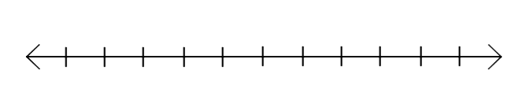

5. ________________