Name: ______________________________ Date: _____________

Teacher: ____________________________ CC Algebra

Cumulative Review #1.4

Show work for all questions for full credit
& write your answers on the lines provided!!!
(If you feel no work is needed you must explain your reasoning.)

______1. What is the first step in simplifying the expression (2 – 3 x 4 + 5)²?

A. square 5 C. subtract 3 from 2
B. add 4 and 5 D. multiply 3 by 4

______ 2. Mr. Stanton asked his students to write an algebraic expression on a piece of paper.
He chose four students to go to the board and write their expression.

Robert wrote: 4(2x + 5) ≥ 17
Meredith wrote: 3y − 7 + 11z
Steven wrote: 9w + 2 = 20
Cynthia wrote: 8+10−4 = 14

Which student wrote an algebraic expression?

A. Robert
B. Meredith
C. Steven
D. Cynthia

3. Find (w² − w + 1) + (w³ − 2w² + 99). Write your answer in standard form.

4. A method for solving 5(x – 2) – 2(x – 5) = 9 is shown below. Identify the property used to obtain each of the two indicated steps.

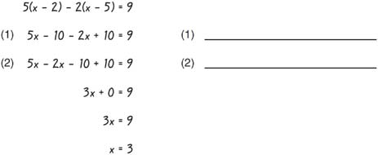

5. Find w² (w³ − w + 1). Write your answer in standard form.

