Name ______________________________ Date _____________
Teacher ____________________________ CC Algebra
Cumulative Review # 2.9

Show work for all questions for full credit
& write your answers on the lines provided!!!
(If you feel no work is needed you must explain your reasoning.)

1. What is the domain of the following function?
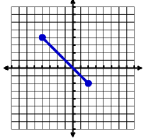
- $-1≤x≤6$
- $\left\{1, 2, 3, 4, 5\right\}$
- $-4≤x≤2$
- $-4≤y≤2$

1. ___________________

2. Write a compound inequality that represents the following phrase.
“All real numbers that are between –8 and 4 inclusive”

  - –8 < n ≤ 4 c. –8 ≤ n ≤ 4
  - –8 < n < 4 d. –8 ≤ n < 4
2. ___________________

3a. Karen makes $5 per hour babysitting and $12 per hour giving music lessons. One weekend, she
worked a total of 18 hours and made $139. Write a system of equations to represent the situation.

3a. _________________________

3b. Use the system you wrote in part a to find out how many hours did she spend babysitting & how many hours she spent giving music lessons.

3b. ___________________________

4. Evaluate ${2x}^{3}+3x-1y$ when x = -2 and y = -3

4. ____________________________

