Name: _________________________________________________ February 12, 2018
Teacher: _______________________________________________ CC Algebra

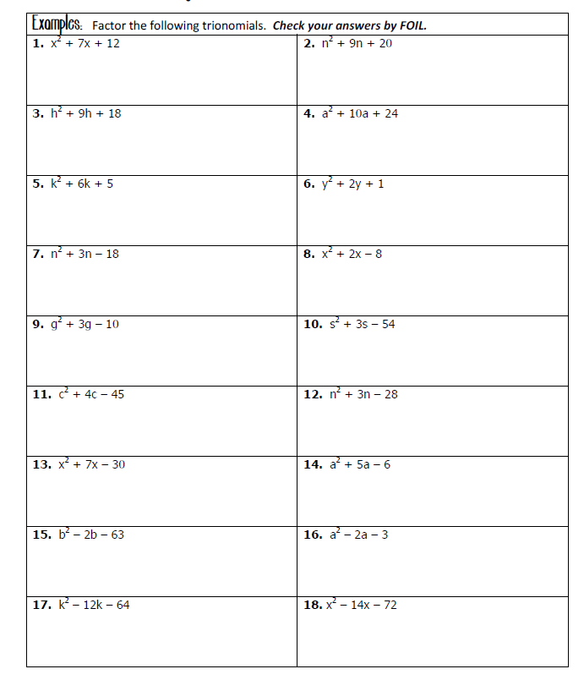
Factoring Trinomial Practice – Homework

