Name: January 17, 2018
CC Algebra

Transformations Practice

1) In each of the boxes below sketch a diagram and write the equation for the named parent functions.
Quadratic | Square Root | Absolute Value | Cubic | Cube Root | Exponential

2) For the following state the transformation given the equation.

a) $y= -{(x+2)}^{2}$

b) $y= \frac{1}{2}\sqrt{x}-3$

c) $y= \left|x-5\right|+1$

3) For the following write the function, $(x)$ , based on the stated transformations.

(a) Write the function $f(x)$ for a quadratic that shifted left 5 units and moved up 2 units.

(b) Write the function $f(x)$ for an absolute value equation that was reflected over the x-axis, and shifted right 1 unit.

(c) Write the function $f(x)$ for a square root function that was made narrower by a factor of 2 and shifted up 3 units.

(d) Write the function $f(x)$ for a quadratic that opens downward, was made wider by a factor of $\frac{1}{4}$, shifted down 6 units and shifted left 2 units.

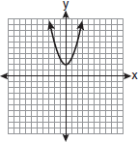
4) For the following graph and then state the domain and range.
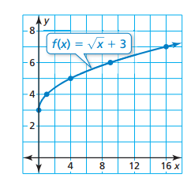
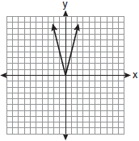

Domain: Domain: Domain:

Range: Range: Range:

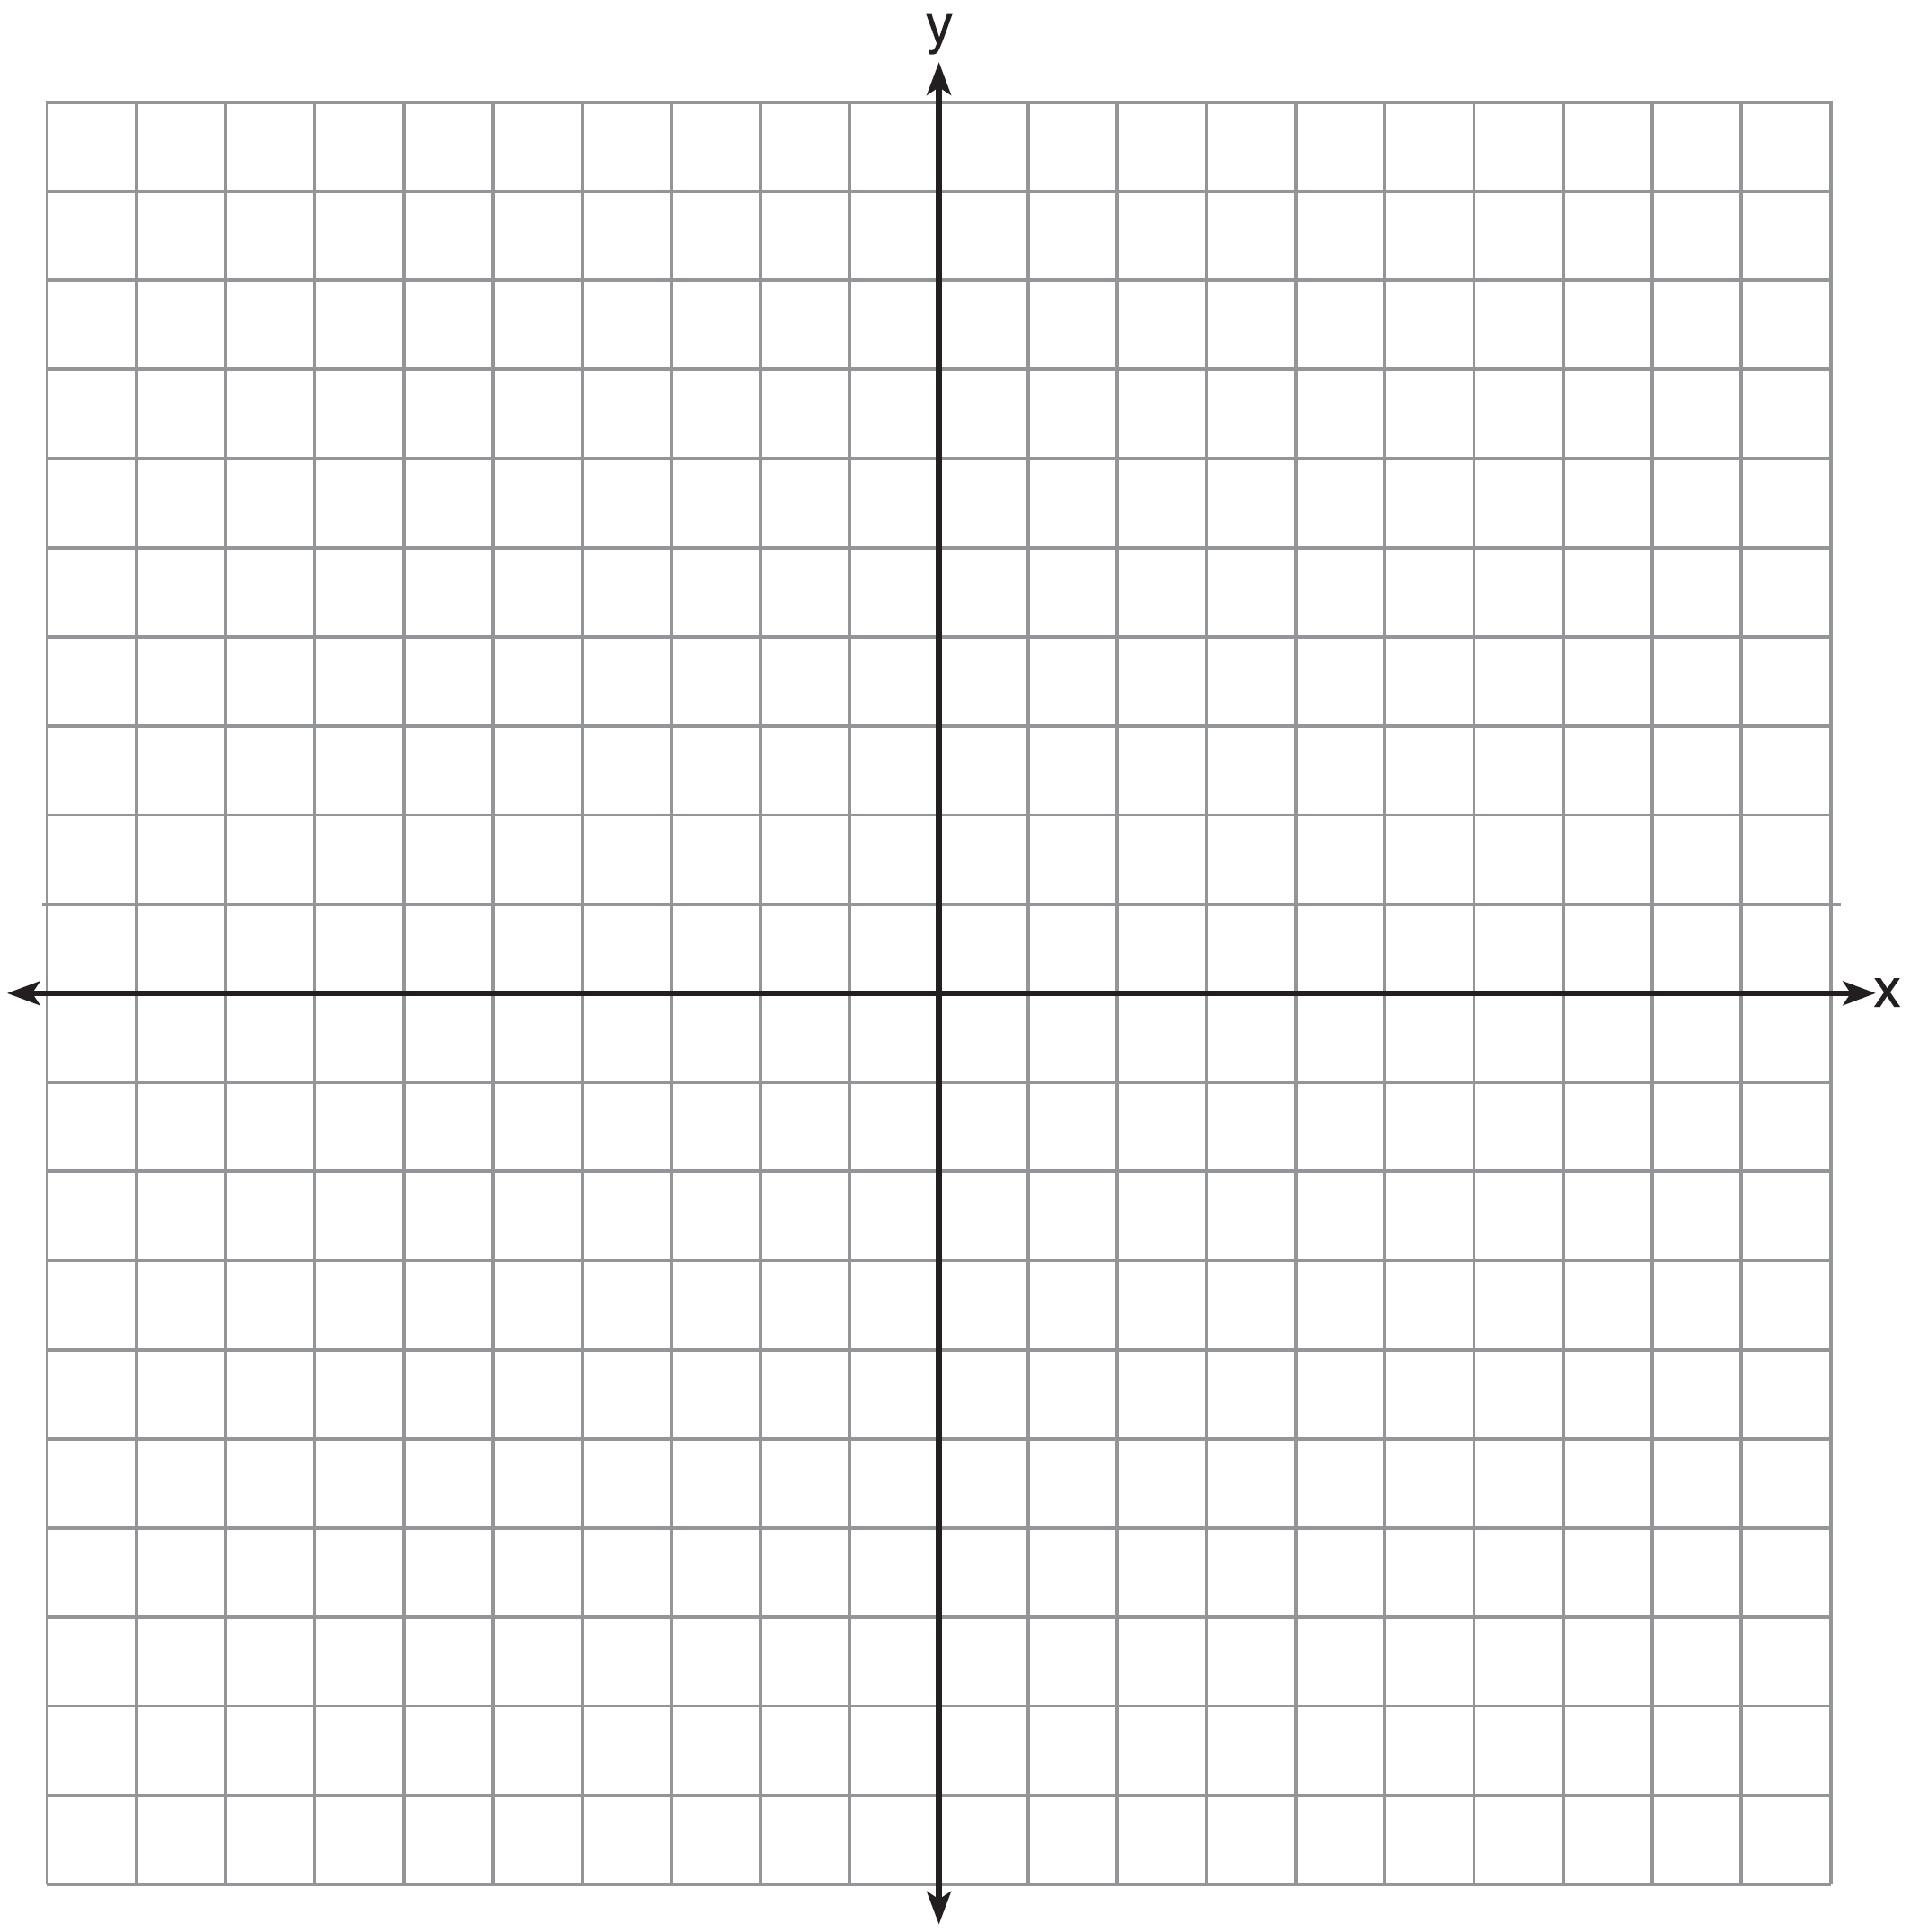
5) Create a table of Values and Draw the graph of on the set of axes below.

(b) State the Domain & Range of the function

Domain:

Range:

6) How does the graph of compare to the graph of ?

A) | The graph of is wider than the graph of , and its vertex is moved to the left 2 units and up 1 unit.
B) | The graph of is narrower than the graph of , and its vertex is moved to the right 2 units and up 1 unit.
C) | The graph of is narrower than the graph of , and its vertex is moved to the left 2 units and up 1 unit.
D) | The graph of is wider than the graph of , and its vertex is moved to the right 2 units and up 1 unit.

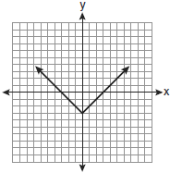
Which 7) Which equation is represented by the graph to the right.

A)
B)
C)
D)

8) Describe the transformation that would produce the graph of the function g from the graph of function f.

- f(x) = 2^{x}; g(x) = 2^{x + 1} + 5

- f(x) = |x|; g(x) = -|x – 3| + 4

9) Describe the relationship between the given functions f and g in terms of vertical and horizontal stretches and shrinkages:

- f(x) = |x| and $g\left(x\right)=\left|\frac{1}{2}x\right|$

- $f(x)=\sqrt{x}$ and $g\left(x\right)=3\sqrt{x}$

10) Graph $g\left(x\right)=-x^{3}$ and explain how it is different from the parent function $h\left(x\right)=x^{3}$

11) Restricted domain & range questions:

- Which domain would be the most appropriate set to use for a function that predicts the number of household online-devices in terms of the number of people in the household?

A) rational numbers B) irrational numbers

C) whole numbers D) integers

- A store sells self-serve frozen yogurt sundaes. The function C(w) represents the cost, in dollars, of a sundae weighing w ounces. An appropriate domain for the function would be

A) nonnegative rational numbers B) nonnegative integers

C) rational numbers D) integers

- A construction company uses the function f(p), where p is the number of people working on a project, to model the amount of money it spends to complete a project. A reasonable domain for this function would be

A) both positive and negative integers B) positive real numbers

C) positive integers D) both positive and negative real numbers

