**Name: _______________________________ Date: _______________**

**CC Algebra – Homework**

**Non Linear Functions**

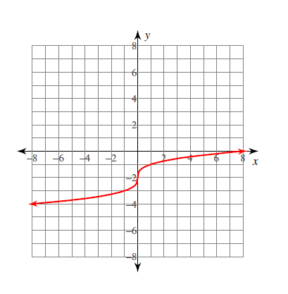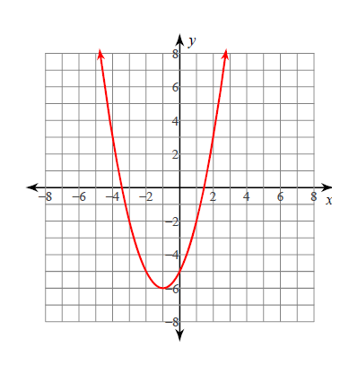**1.** Which of the following graphs represents a square root function?

1. **(c)**

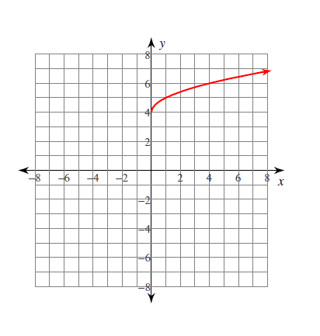

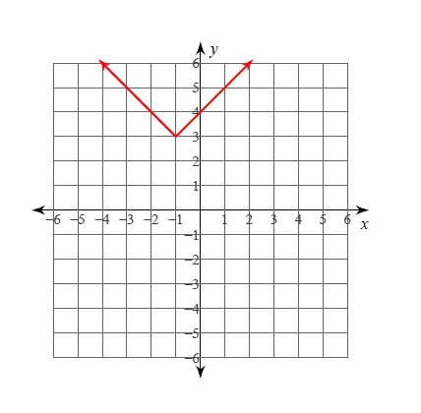

1. **(d)**

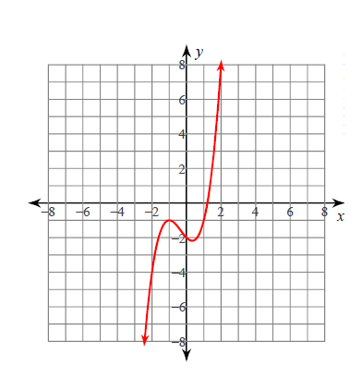

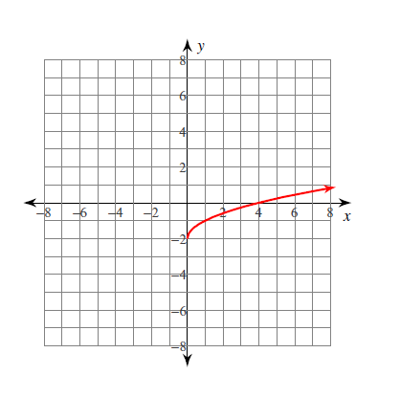**2.** Which of the graphs below could be the graph of y = *x*3 – *x*2 – *x* – 2?

**(a) (c)**

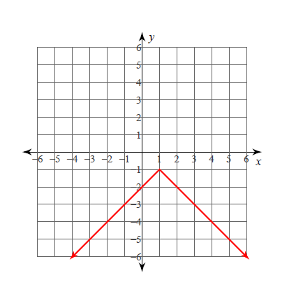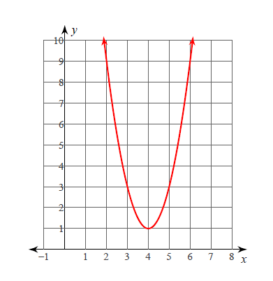

**(b) (d)**

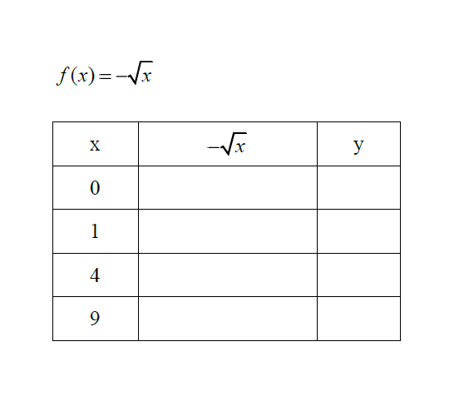

**3.**

**4.** *f*(*x*) = *x*3 + *x*

|  |  |  |
| --- | --- | --- |
| x | *x*3 + *x* | y |
| -2 |  |  |
| -1 |  |  |
| 0 |  |  |
| 1 |  |  |
| 2 |  |  |

**5.** *f*(*x*) = 

|  |  |  |
| --- | --- | --- |
| x |  | y |
| -8 |  |  |
| -1 |  |  |
| 0 |  |  |
| 1 |  |  |
| 8 |  |  |