**Name: ______________________ January 2, 2018**

**Kobrin/Losquadro Math 8**

**Identify each pair of angles as adjacent, vertical, complementary, or supplementary**

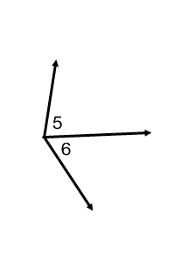

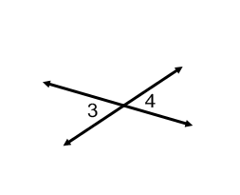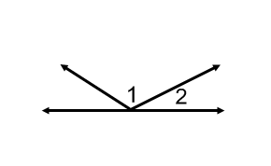**1. 2. 3.**

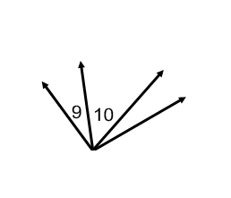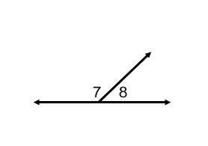

**4. 5.**

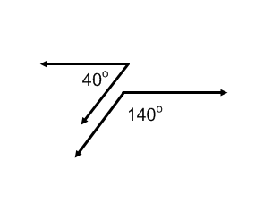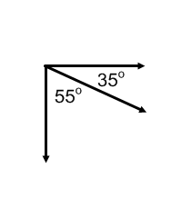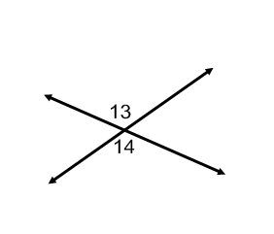

**6. 7. 8.**

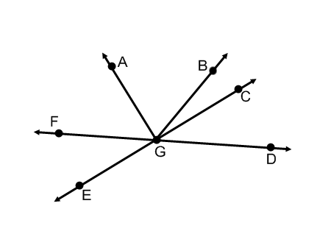**Use the figure at the right to answer each question.**

1. Name two acute vertical angles.
2. Name two obtuse vertical angles.
3. Name a pair of adjacent angles
4. Name a pair of complementary angles.
5. Name an angle supplementary to 