**Name _______________________________ Date __________________**

**Common Core Algebra – Input, Output & Zeros of a Graph Homework**

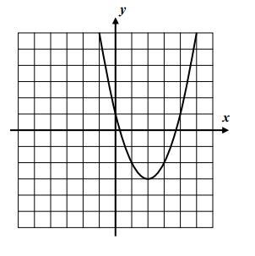

1. 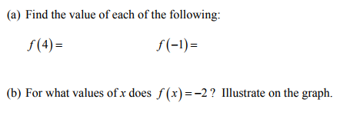
2. 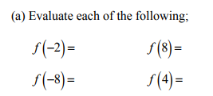

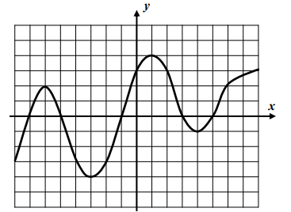

(b) Identify the zeros of the graph