Name: __________________________________ November 22, 2017
Teacher: ________________________________ CC Algebra
Function Evaluating & Operations Practice

- Find f(-4)
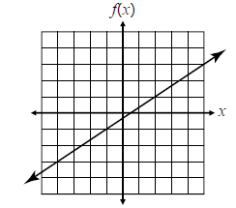

- Find x when f(x) = 4
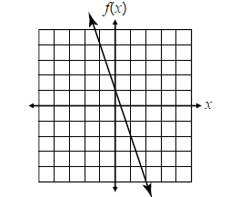

- Find f(2)
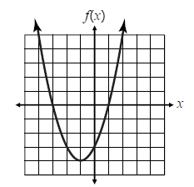

- Find x when f(x) = -2
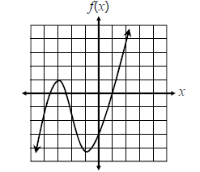

- Given f(x) = 3x – 29. If f(x) = -14, find x.

- Given $f\left(x\right)=-\frac{3}{5}x-17$ If f(x) = -2, find x.

- Given f(x) = 2x² + x – 10, Find f(-4).

- Given f(x) = x³ + 4x, Find f(-2)

- Given $f\left(x\right)=-11-\frac{1}{6}x$. If f(x) = -25, find x.

- Given $f\left(x\right)=15-\frac{5}{2}x$, Find f(6)

- Given $f\left(x\right)=\left|-20-x^{2}\right|$, find f(-8)

- Given f(x) = -5x + 9. If f(x) = 89, find x.

- If f(x) = -5x + 9, what is 2f(x)?

- If $f\left(x\right)= \frac{1}{2}x^{2}$, what does f(2) + f(-2) equal?

- If g(x) = 6x³ – 4x², what is $\frac{g(x)}{2}$?

- Given f(x) = 2x + 2, what is 3f(x) – 8

- Given f(x) = x² + 2x + 1 and g(x) = 5x + 5, find h(x) = f(x) – 2g(x)

- Given f(x) = -3x + 6 and $g\left(x\right)=\frac{1}{2}x$, find h(x) = 4(g(x)) + f(x)

- Given f(x) = 5x and g(x) = 20x³ – 10x² + 15x, find $h\left(x\right)=\frac{g(x)}{f(x)}$.

- Given f(x) = 2x and g(x) = x – 4, find $h\left(x\right)=[f\left(x\right)g\left(x\right)]$.

