Name: ___________________________________ November 27, 2017
Teacher: _________________________________ Math 8

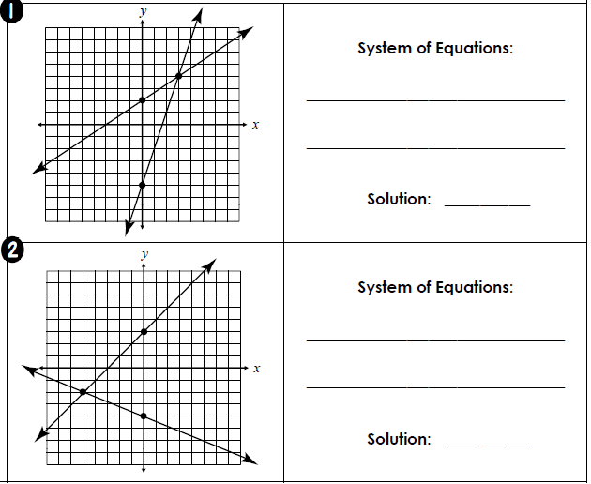
Systems of Equations – Classwork

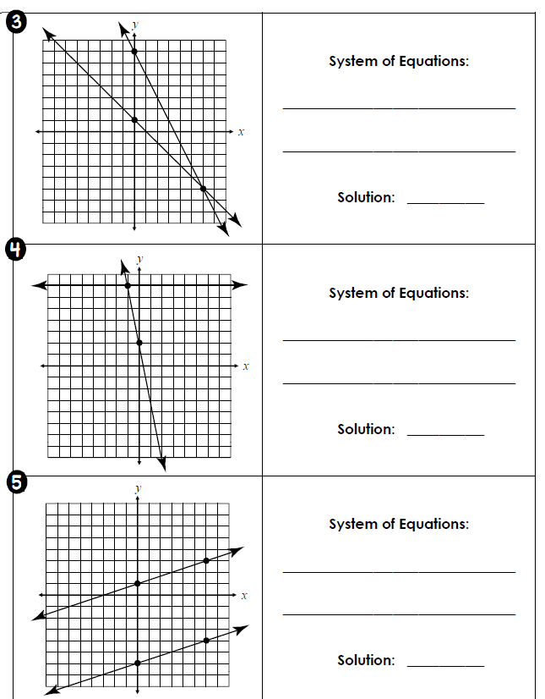

6) Is (2, -7) a solution to system 2x + 3y = -17
3x + 2y = -8

7) Is (1, 2) a solution to the system 7x – 2y = 5
7x – 3y = 4

8) Is (-1, -4) a solution to the system x + 3y = -13
-x – y = 5

9) Is (-3, 4) a solution to the system 2x = y + 2
x + y = 7

10) Is (-3, -8) a solution to the system y = 3x + 1
5x – 2y = 1

Name: _________________________________________ November 27, 2017
Teacher: _______________________________________ Math 8
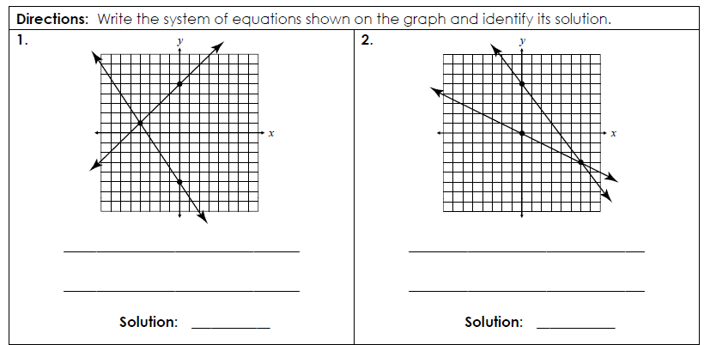

3. Is (3, 4) a solution to the system 2x = y + 2
x + 2y = 7

4. Is (1, -4) a solution to the system x + 3y = -13
x – y = 5

5. Is ( -4, -6) a solution to the system x = 2y
6y – 3x = 12

6. Is (-3, -8) a solution to the system y = 3x + 1
5x – 2y = 1

