**Name: ___________________________________ Date: ___________**

**Common Core Algebra**

**Step Functions**

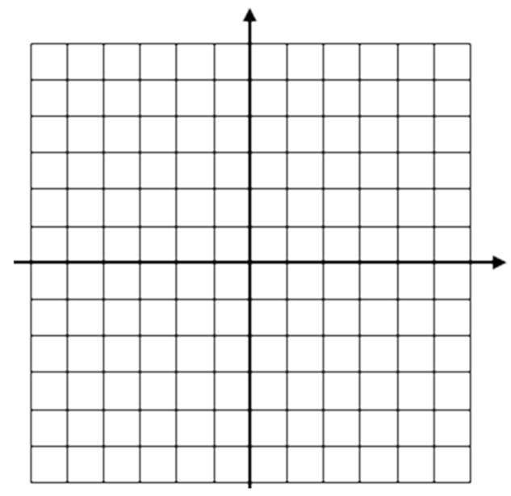**Do Now:**

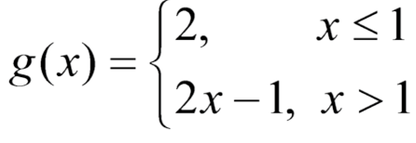**Graph the following function**

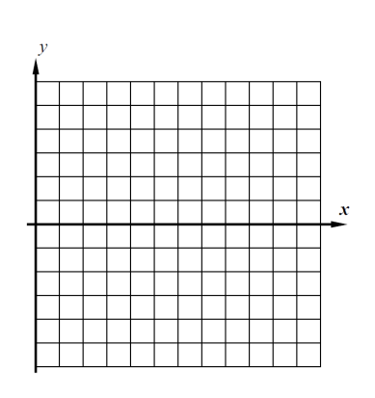1. A step function is defined using the piecewise formula 

(a) Evaluate the following:

*f*(2.7) = *f*(5) =

*f*(3.5) = *f*(0) =

(b) Graph *f*(*x*) on the grid to the right.

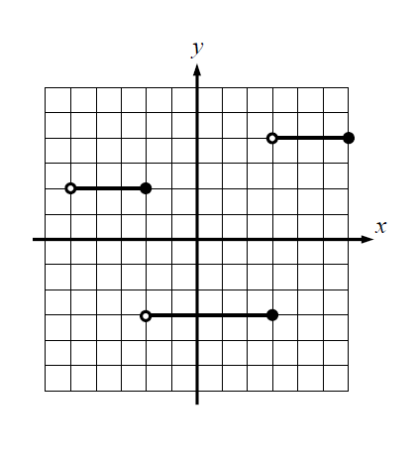2. The step function g(x) is shown on the grid to below. Answer the following questions.

(a) Evaluate each of the following:

*f* (–4) = *f* (–2) =

*f* (2) = *f* (5) =

(b) Write an equation for this step function:



3. Graph the following step function:

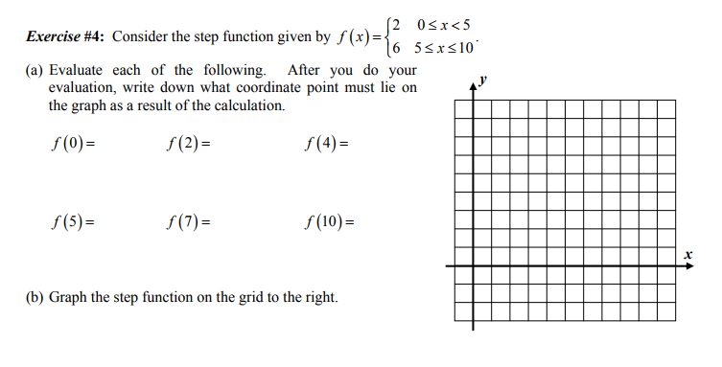4.



5. Graph the following step function: