Name: ____________________________ December 11, 2017

Teacher: __________________________ CC Algebra

**DO NOW**

Max and his younger sister Evie are having a race in their backyard. Max gives his sister a head start and they run for 20 seconds. Max's distance, in feet, is given by *m*(*t*) and Evie's distance, in feet, is given by *e*(*t*).

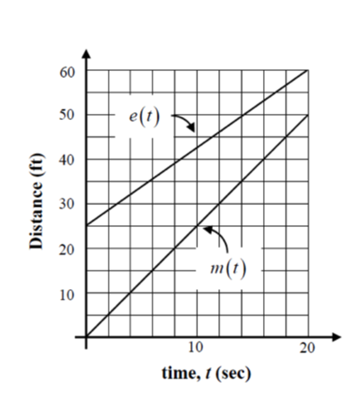

(a) How much of a head start does Max give his sister?

(b) How far does Max run during the 20 second race?

How far does Evie run?

(c) How far does Max run during the 20 second race?

How far does Evie run?

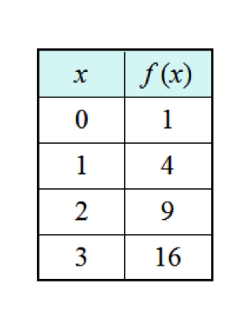

**Average Rate of Change from a Table**

Find the average rate of change from x = 0 to x = 2

Find the average rate of change over the interval 1 ≤ x ≤ 3

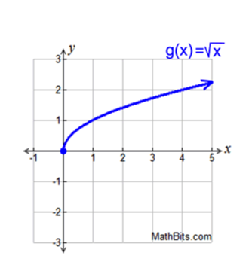

**Average Rate of Change from a Graph**

Find the average rate of change for the interval [0,1]

Find the average rate of change for the interval [1,4]

**Average Rate of Change from an Equation**

Find the average rate of change for the function *f(x) = 1 + 4x*over the interval [0, 3]

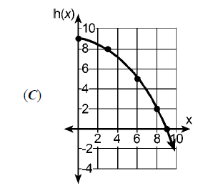**Comparing Average Rates of Change**

Given are three functions f(x), g(x) and h(x)

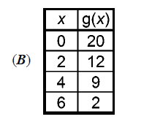

*(A) f(x) = -x2 – 4*

Arrange these three functions in increasing order from least to greatest in value for the average rate of change over the interval .

**Average Rate of Change Word Problem**

A ball thrown in the air has a height of *h*(t) = -16*t*2 + 50*t* + 3 feet after *t* seconds.

A) What are the units of measurement for the average rate of change of *h*?

B) Find the average rate of change of *h* between *t* = 0 and *t* = 2

**Average Rate of Change Practice**

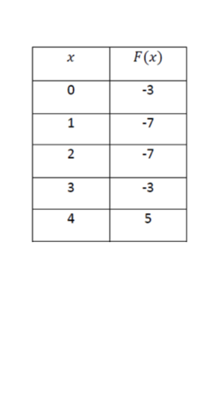

1) Over the interval of 

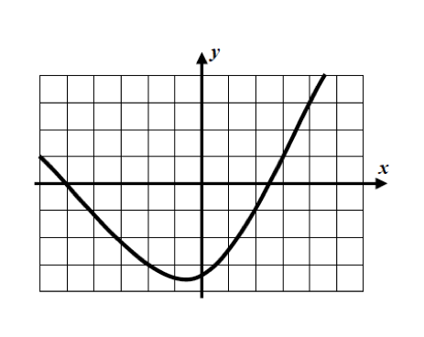2) From x = -6 to x = -2

3) Find the average rate of change for the function  over the interval [-1,2]