Name _____________________________ Date ________________
System of Equations Word Problems Day 2
- The equations 5x + 2y = 48 and 3x + 2y = 32 represent the money collected from school concert tickets sales during two class periods. If x represents the cost for each adult ticket and y represents the cost for each student ticket, what is the cost for each adult ticket?

- The talent show committee sold a total of 530 tickets in advance. Student tickets cost $3 each and the adult tickets cost $4 each. If the total receipts were $1740, how many of each type of ticket were sold?

- Dana paid $3.30 for 2 muffins and a cup of coffee. At the same prices, Damion paid $5.35 for 3 muffins and 2 cups of coffee. What is the cost of a muffin and a cup of coffee?

- The cost of 3 tacos and 1 juice is $7. The cost of 4 tacos and 2 juices is $10. Find the cost of 1 taco and 1 juice.

- One day, an electronics store ships 4 identical laptop computers and 5 identical monitors, for a combined weight of 60 pounds. Another day, it ships 2 laptop computers and 4 monitors, for a combined weight of 42 pounds. What is the weight of one laptop and the weight of one monitor?

- Kiana and Jacobi each have a collection of identical red marbles and identical blue marbles. Kiana’s collection of 12 red marbles and 8 blue marbles has a mass of 70 grams. Jacobi’s collection of 20 red marbles and 12 blue marbles has a mass of 110 grams. What is the mass of each color marble?

- A test has twenty questions worth 100 points. The test consists of True/False questions worth 3 points each and multiple choice questions worth 11 points each. How many multiple choice questions are on the test?

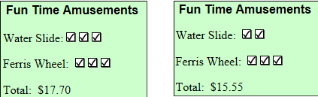
- Bill and Steve decide to spend the afternoon at an amusement park enjoying their favorite activities, the water slide and the gigantic Ferris wheel. Their tickets are stamped each time they slide or ride. At the end of the afternoon they have the following tickets:

