Name: ______________________________ November 16, 2017
Teacher: ____________________________ Math 8

Writing Linear Equations – Day 2
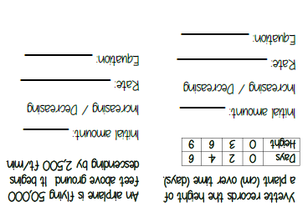

3) A computer repair shop charges a $25 fee in addition to $40 per hour to service a computer.
A) Write an equation to represent the total cost to service a computer

B) How much would it cost to have a computer fixed if it took the repair shop 6 hours.

4) An online photo printing shop charges $0.15 per print in addition to a $2.95 shipping charge.
A) Write an equation to model the total cost for printing pictures.

B) How much will it cost to print 250 photos?

5) Mark bought a season ticket to the ski resort for $395, however, he must pay $25 to rent skis each time he goes skiing.
A) Write an equation to model the total cost that Mark will pay for skiing this season.

B) What is Mark's total cost if he goes skiing 12 times this year?

6) Jane bought a car with 23000 miles on it. She determined that she typically drives 12000 miles per year.
A) Write an equation to show the number of miles on Jane’s car after each year she drives it.

B) How many miles will be on Jane’s car after 5 years?

7) A truck rental company charges $19.95 to rent a truck plus $0.24 per mile driven.
A) Write an equation to represent this situation.

B) Find the cost to rent a truck a drive 188 miles.

8) Eva started a savings account with $500. She plans to save $75 each month.
A) Write an equation to show how much money is in Eva’s savings account at the end of each month.

B) Find the total balance after 2 years.

9) Aidan rents games from a rental service at a cost of $3 per day after a one-time $10 membership fee.

A) Write a linear equation that represents the situation.

B) Find the cost of renting for 12 days

