Name: ______________________________ Date: ____________

Teacher: ____________________________ CC Algebra

**Systems of Equations**

Solve the given system of equations graphically & CHECK

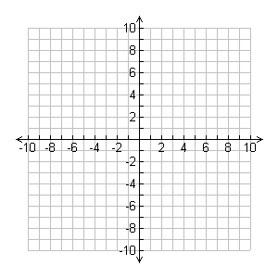

1. *x – 3y = 5*

*2x = 1 – 3y*



1. **

*x + 2y = 11*

**

1. *y = x + 5*

*x – y = 2*



1. *x + 2y = 4*

