Name: ________________________________ November 8, 2017
Teacher: ______________________________ CC Algebra

Do Now
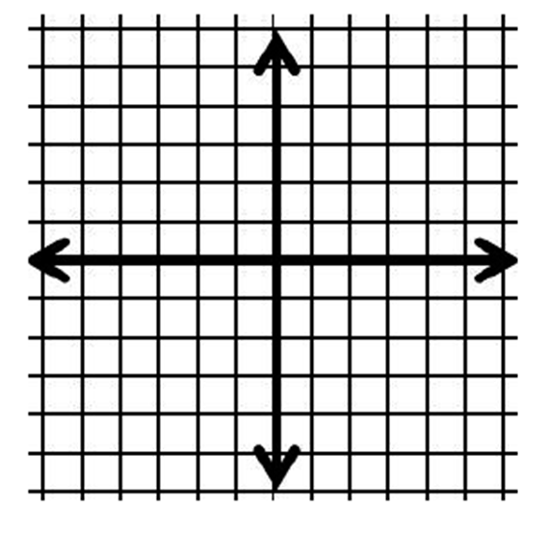
- Graph y – 3 < 2x

- Is the point (5, 1) in the solution set?

Name: _________________________________ November 8, 2017
Teacher: _______________________________ CC Algebra

Graphing Linear Inequalities – Classwork
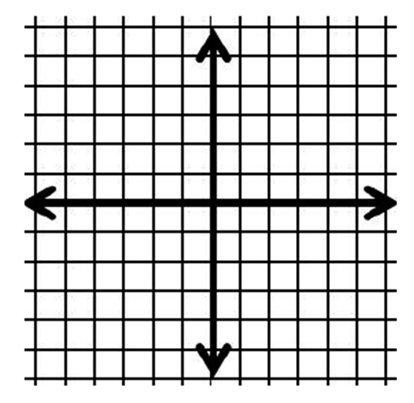
- Graph
y > 2x – 2
-3y ≥ x – 3

State a point in the solution

- Graph
x – y ≤ 8
y < 3x

Is the point (2, 6) in the solution set?

- Graph
3x + y < 3
x ≤ 1

State a point in the solution set.

- Graph
x + y < 1
y > x + 3

Is the point (3, 2) in the solution set?

- Graph
y – 3 < 2x
-2y ≤ x + 2

State a point in the solution set.

