Name: _____________________________________________ Date: _____________
CC Algebra

Graphing Systems of Equations – Real World Problems

Do Now
A cab company charges a $4 boarding rate in addition to its meter which is $3 for every mile
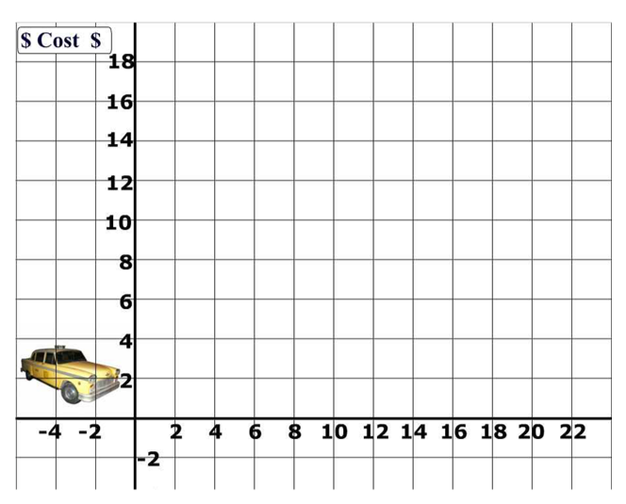
A) Write an equation to represent the
company's rate

B) Graph the equation

