Name: _____________________________ Date: ______________

Teacher: ___________________________ Math 8
Cumulative Review # 3.3
Show work for all questions for full credit
& write your answers on the lines provided!!!
(If you feel no work is needed you must explain your reasoning)

1. | Write the equation of a line that passes through the points (0, 9) and (3, -3).
 | A. | y = -4x + 15
 | B. | y = -4x + 9
 | C. | y = 2x + 9
 | D. | y = 2x - 9

1 ._________________________

2. | Which table shows pairs of values belonging to the solution set of 2x - y = 7?
 | A. | 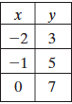 | C. | 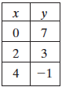
 | B. | 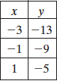 | D. | 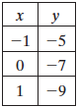

2 ._________________________

3. | Write in coordinate notation the translation of Point A (-3, 5) to Point A’ (2, 1).
3 ._________________________

4. | Solve and Check the equation 10(2y + 2) – y = 2(8y – 8)

4 ._________________________

5. | Solve the following system of linear equations:  -20x + 2y = 6  -10x + y = 7

5 ._______________________

