Name: ______________________________ Date: _____________
Teacher: ____________________________ Math 8
Cumulative Review #3.1
Show work for all questions for full credit
& write your answers on the lines provided!!!
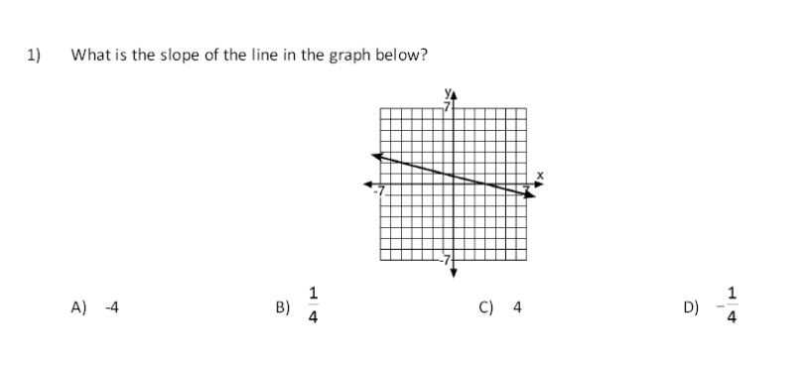
(If you feel no work is needed you must explain your reasoning.)

1. _____________

2. Which system of equations has no solution?

A. y = 4x – 9 and y + 4x = 3
B. y = 2x and 2y = x – 9
C. y + x = 0 and y = x
D. y = 3x + 7 and y – 3x = −2

2 _______________

3. Is the point (−4, −5) on the graph of the line whose equation is y – 2x = 6?

3. _______________

4. Six times a number decreased by seven is the same as four times the number increased by three. What is the number? [Only an algebraic solution will be accepted.]

4. _______________

5. Solve the following system of equations algebraically and check your answer.

5x + y = 15
3x + y = 11

5. _______________

