Name: ______________________________ Date: _____________

Teacher: ____________________________ Math 8

Cumulative Review #2.6

**Show work for all questions for full credit**

**& write your answers on the lines provided!!!**

(*If you feel no work is needed you must explain your reasoning.)*

1. Julia’s mom gave her $100 to spend at the mall. She bought two shirts for $19.99 each, a jacket for $38.94, and shoes for $16.99. Excluding tax, which is the best estimate for how much change Julia will receive after these purchases?

A. Less than $5

B. Between $5 and $10

C. Between $10 and $15

D. She owes more than $100

1. __________

2. Ben has 24 pounds of bird seed. He puts 1 pounds of seed in his feeders each day. How many days will he be able to fill his feeders?

A. 10days

B. 14 days

C. 16 days

D. 18 days 2. __________

3. The scale in the following drawing of a rectangular room is 2 in.: 4 ft. Find the area of the actual room.

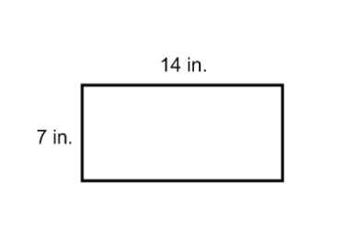

3. __________

4. The number of students at an elementary school in 2001 was 654. In 2007, there were 520 students. What is the percent decrease in the number of students?

4. __________

5. Change 58%: a. to a decimal.

b. to a fraction in simplest form.

5a. _________

5b. _________