Name: ___________________________________ Date: _____________
CC Algebra
Inequality Words to Know

less than more than at most a maximum value
at least greater than the least amount no less than
no more than a minimum value of exceeds the most amount

$$<$$ | $$>$$
$$≤$$ | $$≥$$
Do Now
Directions: Place the words above in the appropriate box.

Inequality Word Problems

1. Paul earns $25.00 per hour at his job. Each
day he spends $10.00 for lunch. Today he
wants to take home at least $215.00 after
paying for his lunch. How many hours will he
have to work to achieve his goal?

2. Sally rented a car for $45.00 a week plus
$0.12 for each mile the car is driven. What is
the greatest number of miles Sally can drive
the car if she wishes to spend at most $105?

3. For what values of x is the area of the
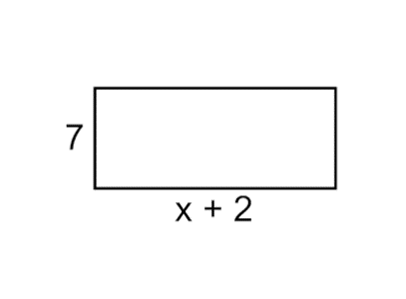
rectangle greater than the perimeter?

4. Two consecutive odd integers have a sum of
more than 26. Find the two smallest odd
integers that will make this true.

5. Sophia types 75 words per minute and is just starting to write a term paper. Patrick already has 510 words written and types at a speed of 60 words per minute. For what number of minutes will Sophia have more words typed than Patrick?

6. You rent a car and are offered 2 payment options. You can pay $25 a day plus $0.15 a mile (Option A) or you can pay $10 a day plus $0.40 a mile (Option B). For what amount of daily miles will Option A be the cheaper plan?

7. Members of the marching band are planning to sell programs at football games. The cost to print the programs is $150 plus $0.50 per program. They plan to sell each program for $2. How many programs must they sell in order to make a profit?

8. The length of a rectangle is 15 and its width is w. The perimeter of the rectangle is, at most, 50. Set up an inequality to find the longest possible width.

9. In a school, the number of girls is 50 more than twice the number of boys. If the school has at most 650 pupils, find the greatest possible number of boys and the greatest possible number of girls in the school.

10. Carol has 3 times as many CDs as Sue. If the total number of CDs they have together is less than 180, find the number of CDs each girl has.

11. Patty needs a total of $80 to buy a bike. She has already saved $35. If she saves $10 per week from her earnings, what is the least number of weeks she must work to have enough money to buy the Bike?

