Name: _________________________________ May 14, 2018

Kobrin/Losquadro Math 8

**The Number Line – Classwork**

1) Graph the following numbers on the number line below

-3.2, -2.2, 0.25, -0.523

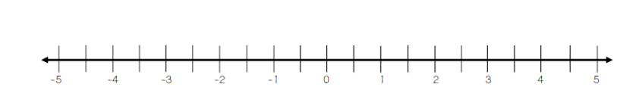

2) Graph the following numbers on the number line below



3) Use <, >, or = to compare each set of numbers

A. -1.99 ⃝ -2.32

B. -0.375 ⃝ 

C. -7.798 ⃝ -7.77

D. 16% ⃝ 0.167

E.  ⃝ -3.3335

F.