**Name: _______________________________ Date: ________**

**CC Algebra**

**Solving Quadratic Equations Review**

1. What values of a, b, c should be substituted in the quadratic formula to solve 3x2 + 5= 2x?
   1. a = 3, b = -2, c = -5 **c.** a = 3, b = 2, c = 5
   2. a = 3, b = 2, c = -5 **d.** a = 3, b = -2, c = 5
2. What number should be added to both sides to complete the square on r2 – 10r = 12?
   1. 6.25 **c.** 36
   2. 25 **d.** 144
3. The expression  can be simplified to
   1.  **c.** 
   2.  **d.** 
4. What number should be added to both sides to complete the square in the equation r2 – 2r = 12?
   1. 1 **c.** 4
   2. 2 **d.** 144
5. What are the zeros of the function f(x) = x2 – 5x – 24?
   1. 8 and –3 **c.** 8 and 3
   2. –8 and 3 **d.** –8 and –3
6. Given the equation 4x2 – 16 = 0, what are the roots?
   1. 16 and –16 **c.** 2 and –2
   2. 4 and–16 **d.** 4 and –4
7. What does it mean if the value of the discriminant is negative?
   1. The quadratic equation has

one real solution

* 1. The quadratic equation has

two real solutions

* 1. The quadratic equations has

no real solutions

* 1. There is an error in the

calculations

1. What is the best first step to solve x2 = 2x + 1 by completing the square?
   1. Put the equation in standard form
   2. Divide both sides by 2
   3. Subtract 2x from both sides
   4. Subtract 1 from both sides
2. Solve the equation using the quadratic formula: 3x2 – 7x + 3 = 0. *(Round your answers to the nearest hundredth)*
3. Simplify the radical 

1. Solve the quadratic equation using the quadratic formula: x2 – 3 = 4x.
2. Solve the quadratic equation by completing the square. Write your answer in radical form, if necessary.

x2 + 10x = 1

1. Solve the quadratic equation by factoring.

3x2 – 4x – 15 = 0

1. Solve the quadratic equation by completing the square.

44 = x2 - 8x

1. Solve the quadratic equation using the quadratic formula 5x2 – 3 = x2 + 5x
2. Given two consecutive positive even integers, it turns out that the square of the larger minus 10 times the smaller is 76. Find the two integers
3. 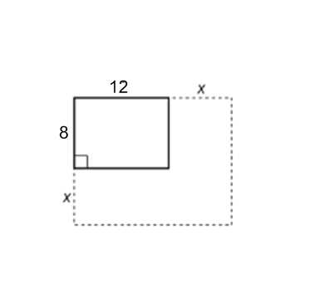A rectangular parking lot measuring 8 m by 12 m is to be increased to an area of 200 square meters. If both the length and the width is increased by the same amount, what is the number of meters, to the nearest tenth, that the dimensions will be increased?