Name: _________________________ January 25, 2018

Kobrin/Losquadro Math 8

Unit 6 Special Angles Test Review

Use the following diagram to answer questions 1 – 10.
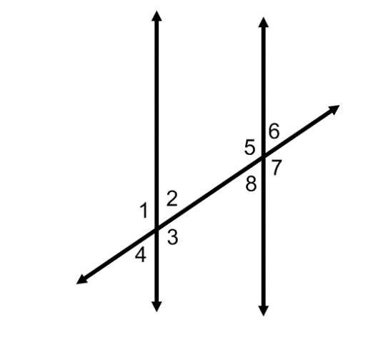

- List all pairs of vertical angles

- List all pairs of corresponding angles

- List all pairs of alternate interior angles

- List all pairs of alternate exterior angles

- If m∠ 6 = 135˚, then m∠ 7 =
- If m∠ 1 = 45˚, then m∠ 8 =

- Which pair of angles is supplementary?
  - ∠1 and ∠3
  - ∠2 and ∠6
  - ∠3 and ∠5
  - ∠4 and ∠7

- Which pair of angles is not congruent?
  - ∠1 and ∠3
  - ∠3 and ∠4
  - ∠4 and ∠6
  - ∠5 and ∠7

- Given x = 20 and y = 5
The Measure of Angle R = 2x + 4y
The Measure of Angle S = 5x + 4y
The two angles must be __________________ angles.
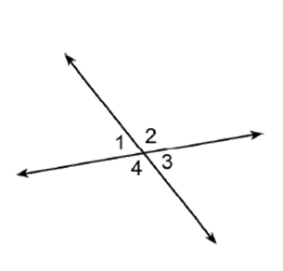
  - Corresponding b) Complementary
c) Congruent d) Supplementary

- Which pair of angles in the given diagram are vertical?
  - 2 and 4 b) 1 and 4
c) 3 and 4 d) 1 and 2

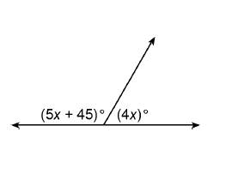
11) Solve for x

12) Solve for x
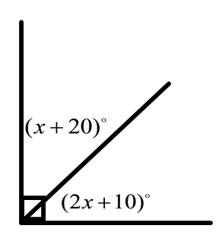

13) Solve for x

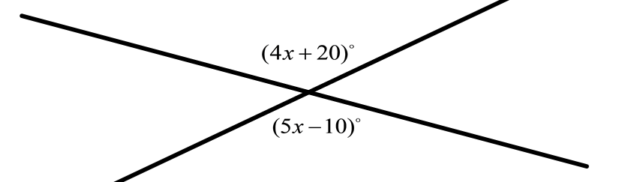

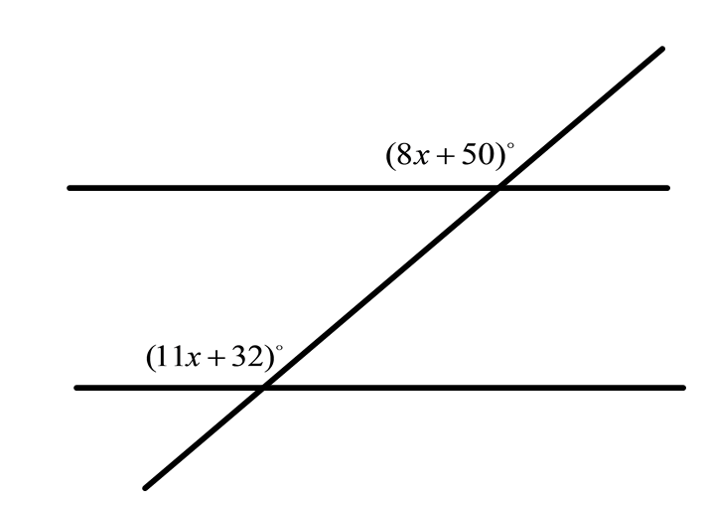
14) Solve for x

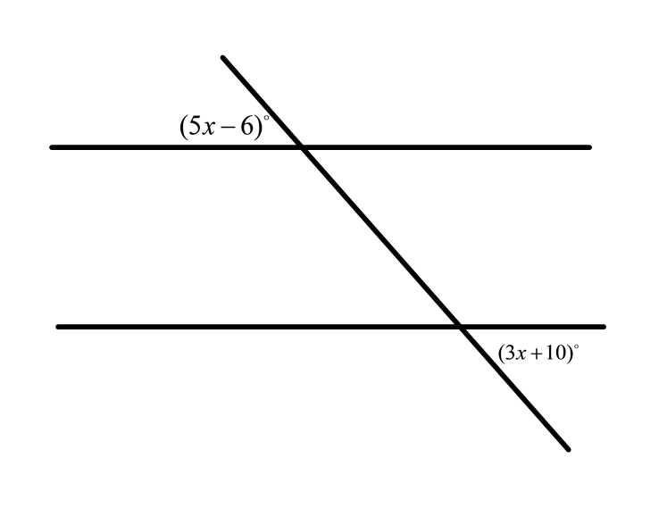

15) Solve for x

16) Solve for x
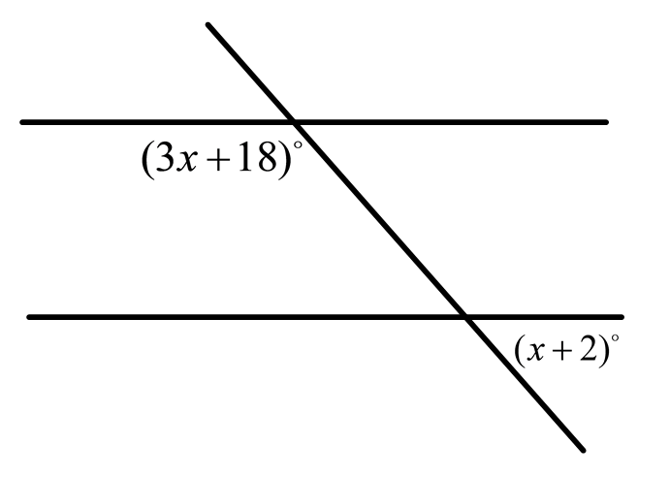

17) Using the accompanying diagram, find the value of x and then find m<AGE

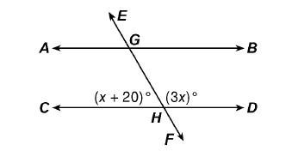

18) Using the accompanying find the measure of the following angles

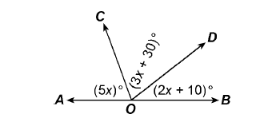
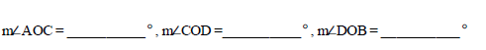

19) The larger angle of two supplementary angles has a measure of 20° more than the measure of the smaller angle. Find the number of degrees in the measure of the smaller angle.

20) Two complementary angles have the measures in the ratio 5:4. What is the measure of the smaller angle?

21) Angle R and Angle S are vertical to each other. m<R = 4x + 10 and m<S = 14x – 30 Find the measure of x and then the measure of <R.

22) Two angles are complementary. Of the measure of one angle is 20 more than the measure of the second angle, what is the number of degrees in the measure of the smaller angle?

Answer Key
- 1, 3 2, 4 5, 7 6, 8

- 1, 5 2, 6 4, 8 3, 7

- 2, 8 2, 5

- 1, 7 4, 6

- 45°

- 135°

- D

- B

- D

- A

- x = 15

- x = 20

- x = 30

- x = 6

- x = 8

- x = 40

- x = 40 <AGE = 60°

- x = 14 <AOC = 70° <COD = 72° <DOB = 38°

- Smaller Angle = 80°

- Smaller Angle = 40°

- <R = 26°

- Smaller Angle = 35°

