**Name: ______________________________________ December 20, 2017**

**Math 8**

**Unit 5 - Systems of Equations Test Review**

1. Which step can be taken to eliminate a variable from the linear system below?

-4x + 2y = -2

4x – 3y = -1

1. Add to eliminate variable x
2. Subtract to eliminate the variable x
3. Add to eliminate the variable y
4. Subtract to eliminate the variable y

2. What point is the intersection of the graphs of the lines *y* = -x + 7 and *y* = x + 3?

1. (3,4) c) (2,5)
2. (-2,1) d) (0, 0)

3. On one day, 4 gardeners and 4 helpers earned $360. On another day, the same number of hours and the same rate of pay, 5 gardeners and 6 helpers earned $480. How much does a gardener and a helper earn each day?

a) 4x + 4y = 480 c) 4x + 4y = 360

5x + 6y = 360 5x + 6y = 480

b) 4x + 6y = 480 d) 4x + 6y = 360

5x + 4x = 360 5x + 4x = 480

Solve the following systems of equations graphically.

4) 3x + y = -10 5) y = - 2x + 3 6) x + 2y = 6

y = 2x + 5 y = -2x – 4 -2x + y = 8



So

S

Solve using the substitution method and check.

7) y = 2x – 1 8) 3x + 2y = 20

2x + y = 3 x – y = -5

Solve using the elimination method and check.

9) 3x – y = 30 10) 2x – 9y = 15

-3x + 7y = 6 -x + 3y = -6

Solve each of the following problems. Make sure to set up appropriate equations and SHOW ALL WORK!

11) The sum of two number is 36. Twice the first number minus the second is 6. Find the numbers.

12) Mason decides to open up his own fast food restaurant titled “Mason’s Burgers”. Mason’s Burgers sells three hamburgers and two milkshakes for $3.35. Two hamburgers and two milkshakes cost $2.60. Find the cost of each item.

**Answer Key**

1. A
2. C
3. C
4. (-3, -1)
5. No Solution
6. (-2, 4)

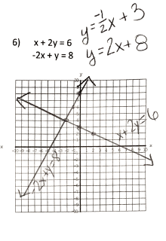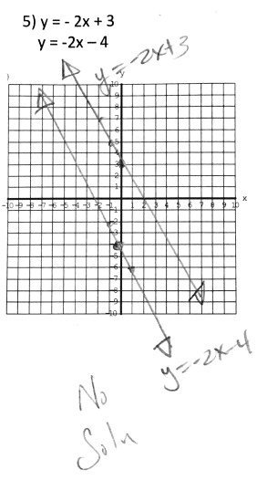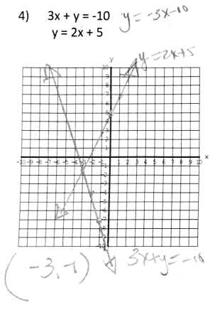

1. (1, 1)
2. (2, 7)
3. (12, 6)
4. (3, -1)
5. 14

22

1. Hamburger $0.75

Milk Shake $0.55