**Name: ___________________________________________ Date: _______________________**

**Losquadro/Kobrin Math 8**

**Unit 4 - Review for System of Equations Quiz**

1. Which ordered pair is the solution to the system of equations



1. (3, -2) B. (2, -3) C. (2, 2) D. (-1, 3)

**2.** Edith is using substitution to solve the system of equations below. What should the first

step be?



A. 

B. 

C. 

D. 

Solve each of the following systems graphically.

1. y = 2x – 1 **4.** y = x + 3

y = -x + 5 -x + 2y = -6

1. 9x + 3y = 6 **6.** 8x + 4y = -20

y = -3x + 2 6x + 6y = -18

1. Solve each of the following systems algebraically and check.

SOLVE CHECK

|  |  |
| --- | --- |
| a. 4x + y = 19  y = 2x - 5 |  |
| b. x = 3y + 3  -3x + y = 7 |  |
| c. y = 5x – 12  y = -2x + 16 |  |

|  |  |
| --- | --- |
| d. y = 4x – 11  4x – y = 11 |  |
| e. x + 3y = 7  -4x – 8y = -20 |  |
| f. 2x + y = 7  y = -2x - 6 |  |

**Unit 4 – Systems Answer Key**

1. C
2. 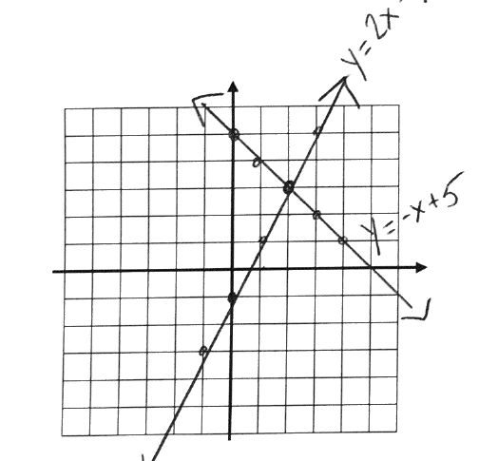A
3. (2,3)
4. 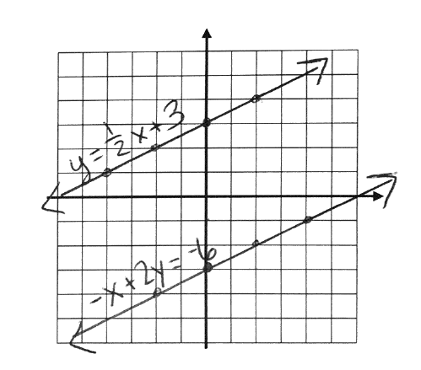No Solution
5. 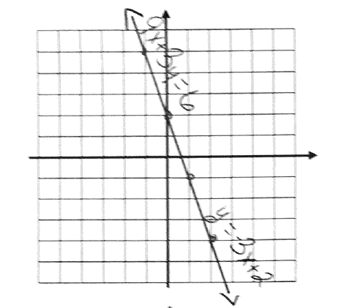Infinite # of Solutions
6. (-2, -1)

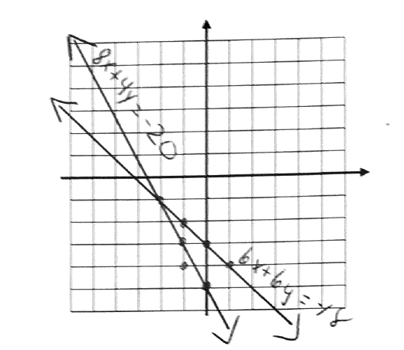

1. **a.** (4, 3)

**b.** (-3, -2)

**c.** (4, 8)

**d.** Infinite # of Solutions

**e.** (1, 2)

**f.** No Solution