**Name _______________________________ Date ______________**

**Common Core Algebra – Unit 5 Quiz Review**

**Directions: Determine whether each relation is a function.**

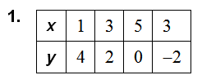

1. Create a mapping diagram for the relation.
2. State the domain & range.



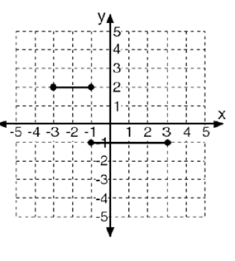

**3.**

**Directions: Find the domain and range of the function represented by the graph. Determine whether the domain is discrete or continuous.**

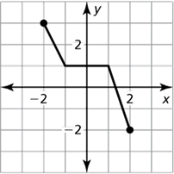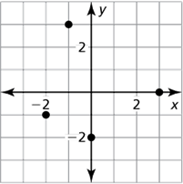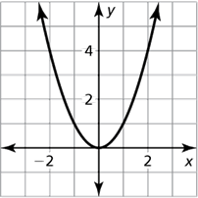

4. 5. 6.

Evaluate the function when:

7. 8. 9.

g(-1) = b(0) = h(-2)

g(4) = b(4) = h(x) = 10

Find the value of *x* so that 

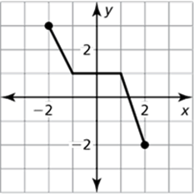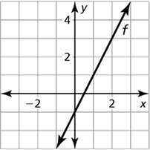10. 11.

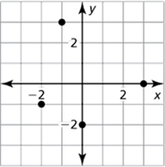Find the output given f(0)

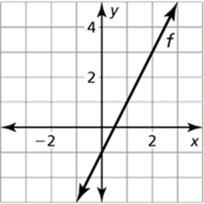12. 13.

14. The function $c=100+ .30m$ represents the cost *c* (in dollars) of renting a car after driving *m* miles.

a. What would the cost be to rent the car and drive 100 miles?

b. How many miles would a customer have to drive for the cost to be $149.50?

15. Given f(x) = 3x - 5 and g(x) = 5x - 1, find h(x) = f(x) + g(x).

16. Given f(x) = 3, g(x) = x + 2, and h(x) = x, find k(x) = f(x) ∙ [g(x) + h(x)].

17. For the initial year of soccer camp, 44 girls and 56 boys enrolled. Each year thereafter, 5 more girls and 8 more boys enrolled in the camp. Let t be the time (in years) since the camp opened. Write a rule for each of the following functions:

* 1. g(t), the number of girls enrolled as a function of time t
  2. b(t), the number of boys enrolled as a function of time t
  3. T(t), the total enrollment as a function of time t

1. For the soccer camp in the previous example, the cost per child each year was $200. Let t be the time (in years) since the camp opened. Write a rule for each of the following functions:
   1. C(t), the cost per child of the camp as a function of t
   2. R(t), the revenue generated by the total enrollment as a function of t
2. 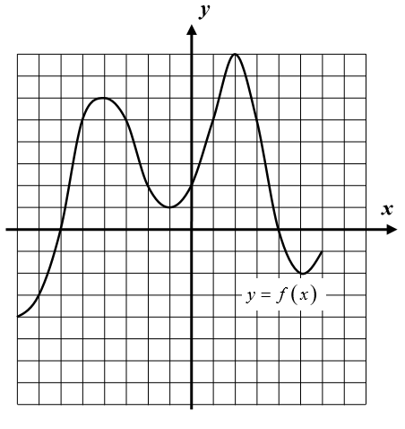The function y = f(x) is shown below.
3. Evaluate each of the following

f(-1) = f(0) =

f(-7) = f(4) =

(b) Use your graph to find all solutions to the equations

f(x) = 5.

(c) State the zeros of the function. Then state the y intercept.

(d) State the domain ________________________ and the range _____________________________

(e) State the absolute minimum ______________ and absolute maximum _______________

(f) Name one increasing interval __________________ and one decreasing interval ____________________

(g) Name one relative maximum (that is not absolute) _____________________________

Name one relative minimum (that is not absolute) ________________________________

1. 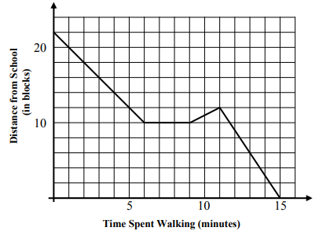Charlene heads out to school by foot on a fine spring day. Her distance from school, in blocks, is given as a function of the time, in minutes, she has been walking. This function is represented by the graph given
2. How far does Charlene start off from school?

(b) What is her distance from school after she has been walking for 4 minutes?

(c) After walking for six minutes, Charlene stops to look for her subway pass. How long does

she stop for?

(d) Charlene then walks to a subway station before heading to school on the subway (a local). How many blocks did she walk to the subway?

(e) How long did it take for her to get to school once she got on the train?