**Name: ________________________ Date: _____________**

**CC Algebra**

**Functions Test Review**

1) The table below shows the average diameter of a pupil in a person’s eye as he or she grows older.

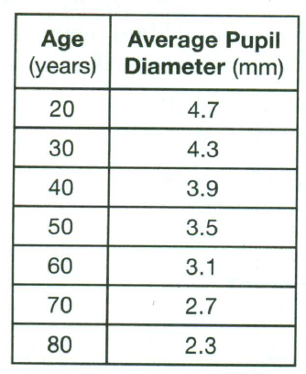

What is the average rate of change, in millimeters per year, of a person’s pupil diameter form age 20 to age 80?

(1) 2.4 (2) 0.04 (3) -2.4 (4) -0.04

2) The function $h\left(t\right)= -16t^{2}+144$ represents the height, $h(t)$, in feet of an object from the ground at *t* seconds after it is dropped. A realistic domain for this function is

(1) -3 < *t* < 3 (3) 0 < *h(t)* < 144

(2) 0 < *t* < 3 (4) all real numbers

3) What is the range of the function f(x) = 5 – 8x when the domain is {-2, 2, 4}?

(1) {-27, -11} (3) {-27, -11, 21}

(2) {-2, 2, 4} (4) {1/8, 3/8, 7/8}

4) If , for what value of *x* does?

(1) 1 (2) -1 (3) 18 (4) -27

5) What is the average rate of change between x = 1 and x = 4 when f(x) = x2 + 5 ?

(1) 5 (2) 9 (3) 3 (4) 15

6) The graph of the function f(*x*) = 3*x* lies in which quadrant(s)?

(1) I, only (2) I and II (3) I and III (4) I and IV

7) Which set of ordered pairs does *not* represent a function?

|  |  |
| --- | --- |
| (1) |  |
| (2) |  |
| (3) |  |
| (4) |  |



8) Which type of function is graphed below?

(1) linear

(2) quadratic

(3) exponential

(4) absolute value

9) Describe how to transform the graph of *f* into the graph of *g*: and 

(1) Shift the graph of *f* left 6units and then reflect across the y-axis.

(2) Shift the graph of *f* left 6 units and then reflect across the x-axis.

(3) Shift the graph of *f* up 6 units and then reflect across the y-axis.

(4) Shift the graph of *f* up 6 units and then reflect across the x-axis.

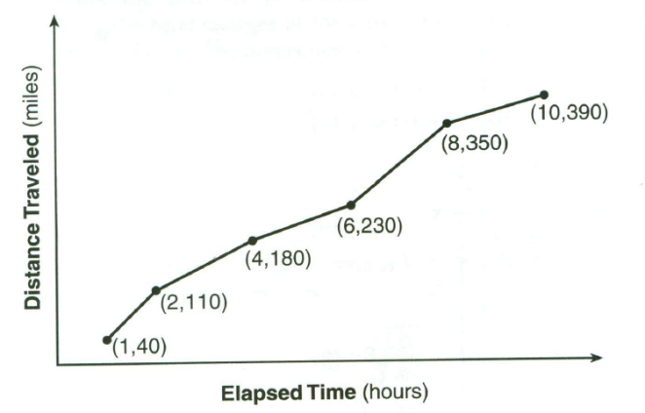10) The Jamison family kept a log of the distance they traveled during a trip, as represented by the graph below.

During which interval was their average speed the greatest?

(1) the first hour to the second hour (3) the sixth hour to the eighth hour

(2) the second hour to the fourth hour (4) the eighth hour to the tenth hour

11) The function f(*x*) is graphed on the set of axes below. On the same set of axes, graph f(*x* + 1) + 2.



12) On the set of axes below, draw the graph of *y* = 2*x* over the interval −1 ≤ *x* ≤ 3.

Will this graph everintersect the *x*-axis? Justify your answer.

13) Decide whether each example represents a linear or exponential function. Then, write the function formula.

|  |  |  |  |  |  |
| --- | --- | --- | --- | --- | --- |
| *x* | 0 | 1 | 2 | 3 | 4 |
| *y* | 0.4 | 0.6 | 0.9 | 1.35 | 2.025 |

a.

Linear or Exponential? y = __________________________

|  |  |  |  |  |  |
| --- | --- | --- | --- | --- | --- |
| *x* | -2 | -1 | 0 | 1 | 2 |
| *y* | 20 | 16 | 12 | 8 | 4 |

b.

Linear or Exponential? y = __________________________

c. Julie gets a pre-paid cell phone. Initially she has a $40.00 balance on the phone. Each minute of

talking costs $0.15.

Linear or Exponential? y = __________________________

d. At the start of an experiment, there are 50 mold cells. Each time an observation is made, the number

of mold cells triples.

Linear or Exponential? y = __________________________

14) a. An adult takes 400 mg of ibuprofen. Each hour, the amount of ibuprofen in the person’s

system decreases by about 29%. How much ibuprofen is left after 6 hours? *Round your answer*

*to the nearest tenth.*

b. You have inherited land that was purchased for $30,000 in 1960. The value of the land

increased by approximately 5% per year. What is the approximate value of the land in the year

2011? *Round your answer to the nearest whole.*

c. The population of Winnemucca, Nevada, can be modeled by P=6191(1.04)t where t is the

number of years since 1990. What was the population in 1990? By what percent did the

population increase by each year?

15) Use the graph below to answer parts (a) – (g).

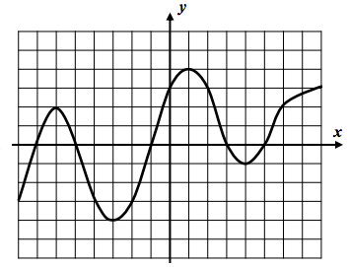

(a) Find all solutions to *f* (x) = -3

(b) Over the interval [-3, 1] is the function increasing or decreasing?_______________________

(c) Give an interval where the function is positive. ________________

(d) Evaluate each of the following: *f* (-5) = __________ *f* (6) = __________

(e) State the domain and range of this function.

Domain: Range:

(f) Find the average rate of change from $x=1$ to $x=4$.