**Name: ______________________________________ Date: ____________**

**CC Algebra**

**Unit 4 - Systems of Equations and Inequalities Review**

1. Which ordered pair is in the solution set of the following system of inequalities?





a) (0,-1) c) (-2,2)

b) (2,2) d) (0,-2)

2 . What point is the intersection of the graphs of the lines *y* = -x + 7 and *y* = x + 3?

1. (3,4) c) (2,5)
2. (-2,1) d) (0, 0)

3. On one day, 4 gardeners and 4 helpers earned $360. On another day, the same number of hours and the same rate of pay, 5 gardeners and 6 helpers earned $480. How much does a gardener and a helper earn each day?

a) 4x + 4y = 480 c) 4x + 4y = 360

5x + 6y = 360 5x + 6y = 480

b) 4x + 6y = 480 d) 4x + 6y = 360

5x + 4x = 360 5x + 4x = 480

Solve the following systems of equations graphically.

4) 3x + y = -10 5) y = - 2x + 3 6) x + 2y = 1

y = 2x + 5 y = -2x – 4 -2x + y = 8



So

S

Solve using the substitution method and check.

7) y = 2x – 1 8) 3x + 2y = 20

2x + y = 3 x – y = -5

Solve using the elimination method and check.

9) 3x – y = 30 10) 2x – 9y = 15

-3x + 7y = 6 -x + 3y = -6

Solve each of the following problems. Make sure to set up appropriate equations and SHOW ALL WORK!

11) Hunter is building a fence around a field in the shape of a rectangle that has a perimeter of 112 feet. Its length is three times its width. Find the length and the width of the field.

12) Mason decides to open up his own fast food restaurant titled “Mason’s Burgers”. Mason’s Burgers sells three hamburgers and two milkshakes for $3.35. Two hamburgers and two milkshakes cost $2.60. Find the cost of each item.

13) Renee is saving up money to buy herself a new hat. After checking her piggy bank, she currently has only nickels and dimes, and a total of $16.50. She has 260 coins altogether. How many of each coin does she have?

14) Ethan and Michael are both saving up money to buy a new graphing calculator (since they know that math classes in high school are going to be really hard!). Ethan has $27 and saves $3 per week. Michael has $13 and saves $5 per week. A) After how many weeks will they have the same amount of money? B) How much money will they have?

**Graph each of the following system of inequalities. Then, name 2 ordered pairs that are solutions and two ordered pairs that are not. Show where they are located on your graph.**

15) x ≥ -2 16) 2x – 3y ≥ 9

y > 5x + 2 2y + x > 6



17) Phillip mows yards for his father’s landscaping business for $10 per hour. He also works at a

bakery for $15 per hour. He can work at most 40 hours per week during the summer. He needs to

make at least $500 per week to cover his living expenses. Graph the system of inequalities that

satisfy the conditions. List three combinations of hours that satisfy the conditions. Show where

 those combinations are on your graph.

18) Connor works for a store that sells socks. He sells *x* packages of knee-high socks for $10 each and *y* packages of crew socks for $5 each. He can only purchase 475 pairs of socks to sell and wants make at least $3125 from selling the socks.

Write a system of inequalities to represent the above stated situation.

Graph the inequalities on the given set of axes.

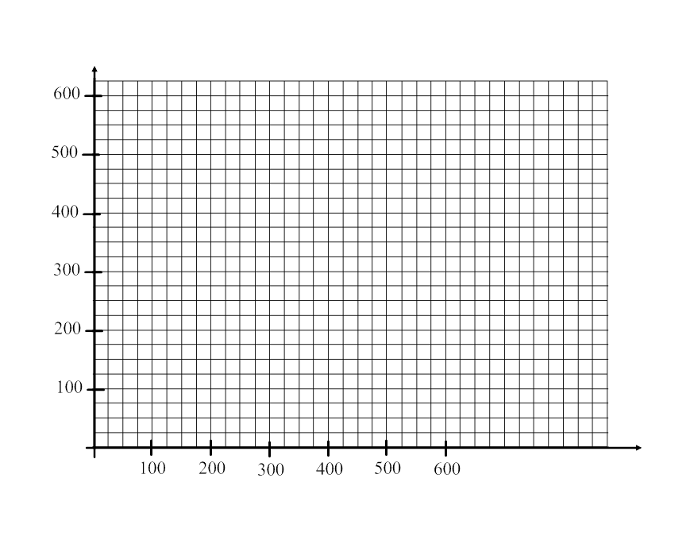

Determine and state one combination of socks that will allow Connor to make at least $3125 while selling no more than 475 pairs of socks.

**Answer Key**

1. B
2. 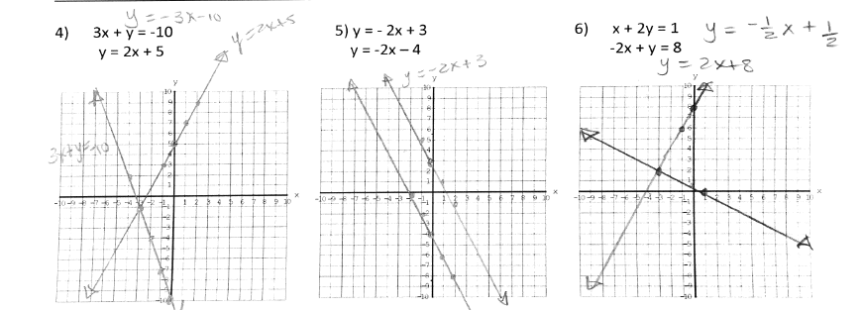C
3. C
4. (-3, -1)
5. No Solution
6. (-3, 2)
7. (1, 1)
8. (2, 7)
9. (12, 6)
10. (3, -1)
11. Width = 14 feet

Length = 42 feet

1. Hamburger $0.75

Milk Shake $0.55

1. 190 nickels

70 dimes

1. **A)** 7 Weeks

**B)** $48

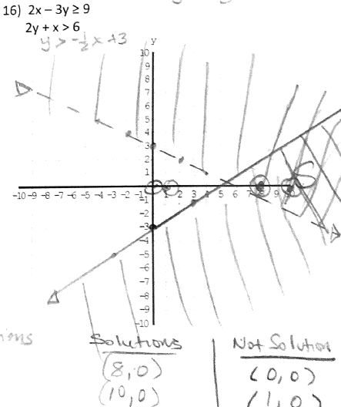

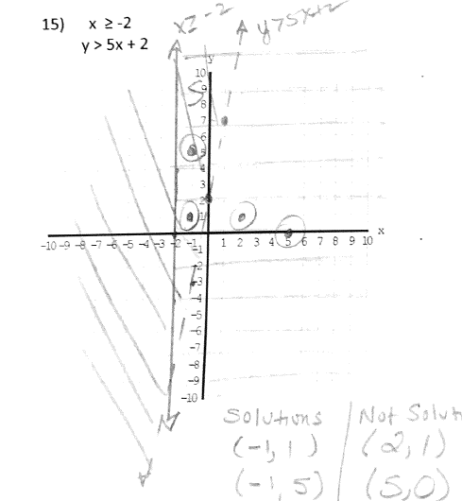

1. 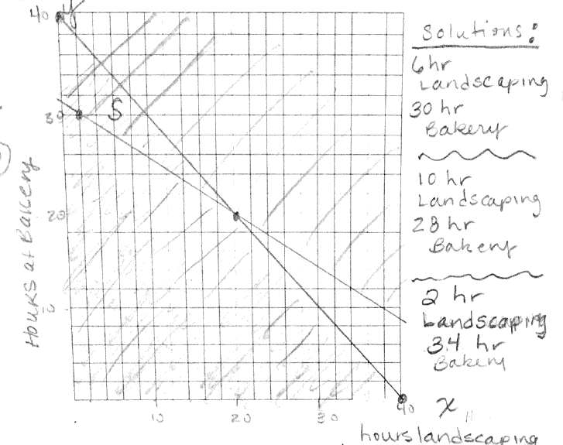

$x+y≤475$

1 $0x+5y≥3125$

