Name: ______________________________ October 19, 2017

Teacher: ____________________________ Math 8

Unit 3 Quiz Review

___1. What Quadrant does the point (-5,4) lie in?

- Quadrant I
- Quadrant II
- Quadrant III
- Quadrant IV

___2. Which of the following equations represents a horizontal line?

- y = -3
- x = 5
- y = 5x -5
- y = -4x

___3. Which of the following is the domain of the following relation?

{ (0,-1), (1,3), (4,2), (9,10), (13,20) }

- {-1, 3, 2, 10, 20}
- {0, 1, 4, 9, 13}
- {0,-1, 3, 9, 20}
- {-1, 3, 2, 10, 13}

___4. Which of the follow equations represents a vertical line?

- x = 9
- y = 10x – 9
- y = 12
- y = -12x

___5. Which Statement is not true about functions?

- The graph fails the vertical line test
- The graph passes the vertical line test
- Every x value has only one y value
- Each member of the domain maps to only one member of the range

___6. For the equation $y= \frac{1}{4}x+4$, what are some values for x that would ensure that y would be a whole number?

- 3, 6, 9, -12
- -5, 0, 5, 10
- -2, 0, 2, 6
- -4, 0, 4, 8

___7. Which of the following is a function?

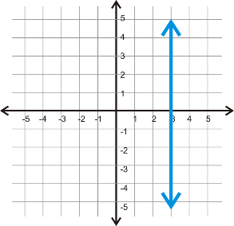
- 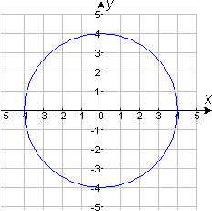 (c) 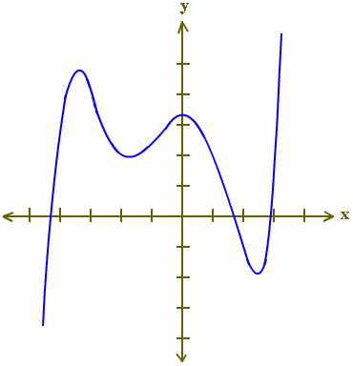
- 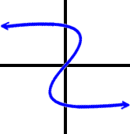 (d)

___8. What is the y-intercept of the following line: $y= \frac{5}{2}x+4$

- $\frac{-2}{5}$ (b) 4 (c) $\frac{5}{2}$ (d) -4

For 8-10: Find the domain and range.

Then create a Mapping Diagram to determine if the relation is a function

8) { (1,-2), (2,-14), (3,-6) } Mapping Diagram:

Domain:____________

Range:_____________

Function?__________

- {(1,2), (4,3), (1,4), (-1,5)} Mapping Diagram:

Domain:_____________

Range:______________

Function?____________
- { (5,0), (-4,0), (0,0), (1,0), (2,0) } Mapping Diagram:

Domain:___________

Range:____________

Function?__________

Pick values for x and make a table, then graph the equation:
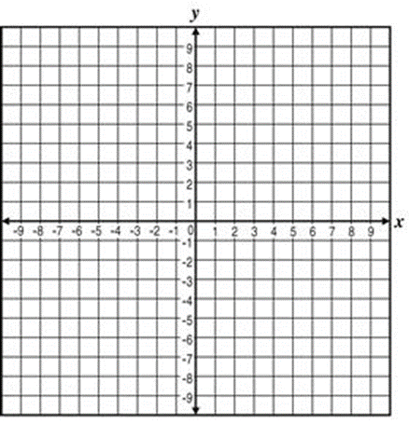
- y = 3x + 2

- $y= \frac{-1}{3}x-3$

- y = -4x + 1

- Find the x and y intercepts algebraically for the line:

2x + 3y = 12

Part A: Graph the following points.
Part B: Draw the line that passes through them
Part C: Identify the x and y intercepts

- { (-4,3), (0,1), (4,-1), (6,-2) } x-intercept____________
y-intercept____________

- { (-6,-4), (-3,0), (0,4), (4,8) }
x-intercept: __________

y-intercept: __________

