Name:
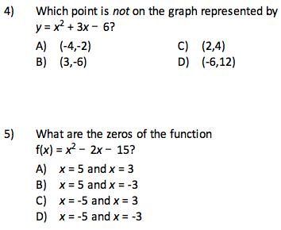
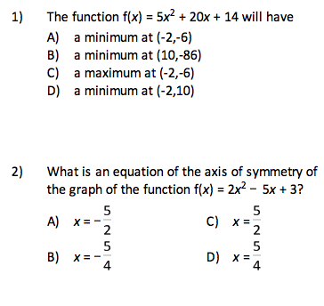

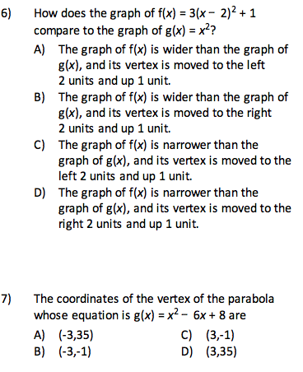
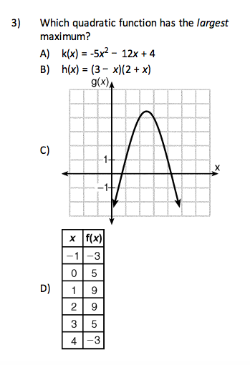
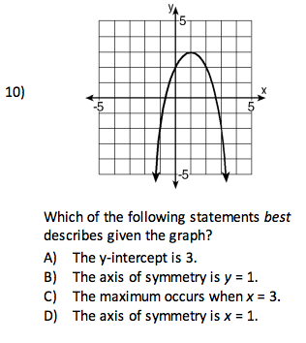
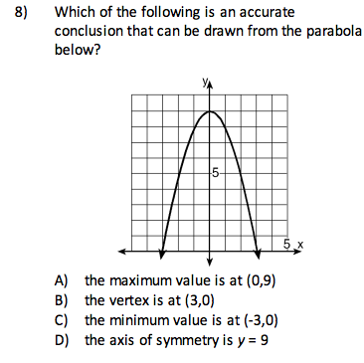
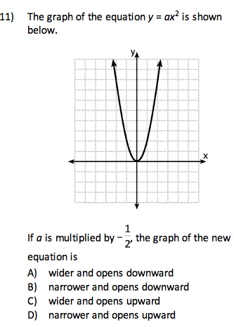
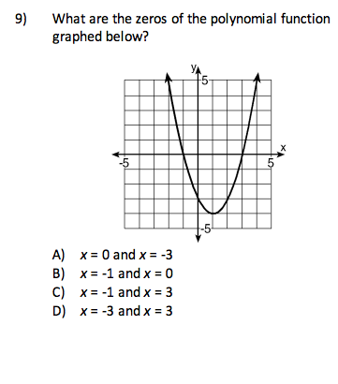
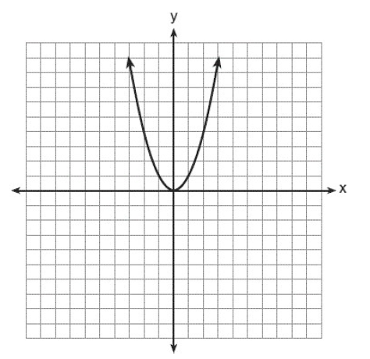
12. The graph of the equation y = x² is shown below.

Which statement best describes the change in this graph when the coefficient of x² is multiplied by 4?
- The parabola becomes wider.
- The parabola will shift up 4 units.
- The parabola becomes narrower.
- The parabola will shift right 4 units.

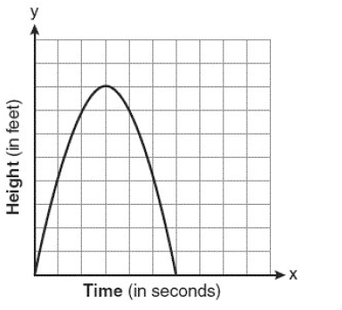
13. The graph below represents the parabolic path of a ball kicked by a young child. What are the vertex and the axis of symmetry for the parabola?

- Vertex: (3, 8), axis of symmetry: x = 3
- Vertex: (8, 3), axis of symmetry: x= 3
- Vertex: (3, 8), axis of symmetry: y = 3
- Vertex: (8, 3), axis of symmetry: y= 3

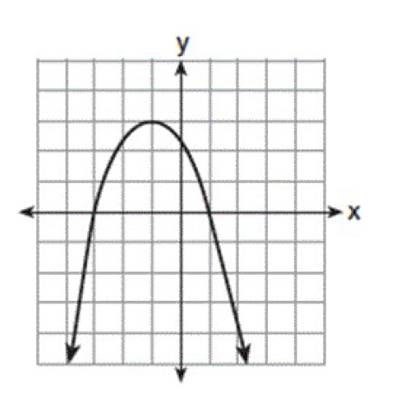
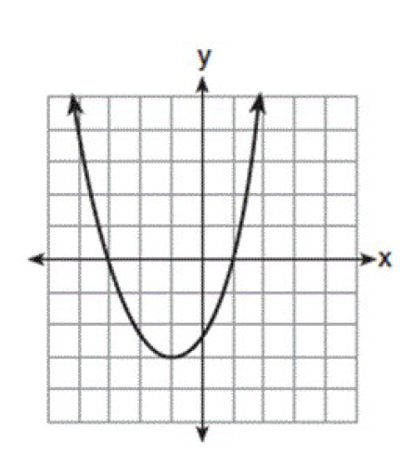
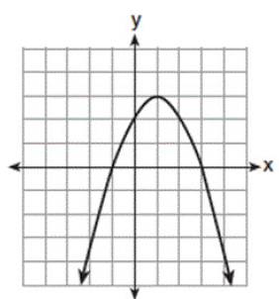
- Which parabola has an axis of symmetry of x = 1?

- c.

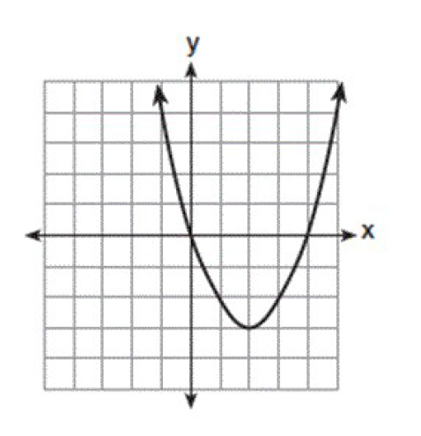
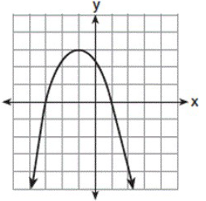
- d.

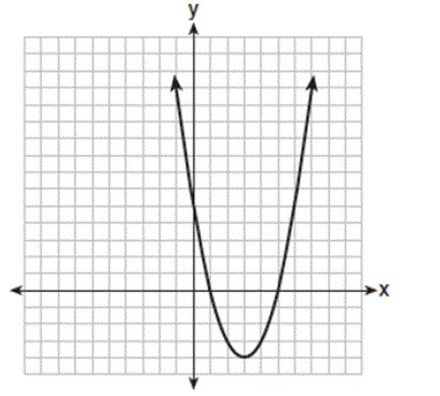
- The equation y = ax² + bx + c is graphed on the set of axes below.

Based on the graph, what are the roots of the equation ax² + bx + c = 0?
- 0 and 5 c. 1 and 5
- 1 and 0 d. 3 and -4

- What is the vertex of the graph of the equation
y = 3x² + 6x + 1?

- (-1, -2) c. (1, -2)
- (-1, 10) d. (1, 10)

- What is the solution of the system of equations
y = x + 5 and y = x² + 5?

a. (0, 5) and (1, 6) c. (2, 9) and (– 1, 4)
b. (0, 5) and (–1, 6) d. (–2, 9) and (–1, 4)

- The graph of a parabola is represented by the equation y = ax² where a is a positive integer. If a is multiplied by –2, the new parabola will become

  - narrower and open downward
  - wider and open downward
  - narrower and open upward
  - wider and open upward

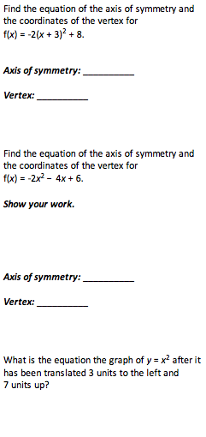
For 19 and 20, convert to vertex form using
21.
completing the square.
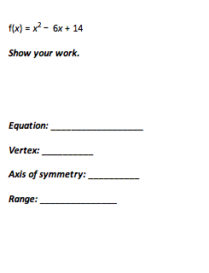

19.

22.

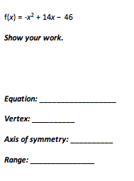

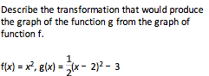
20.
24.
23.
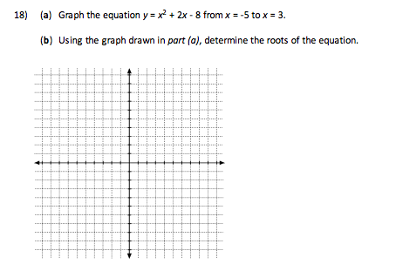
25.

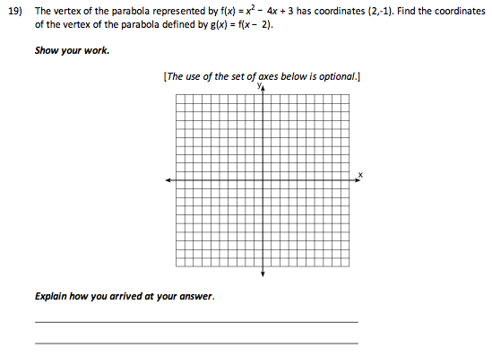
26.
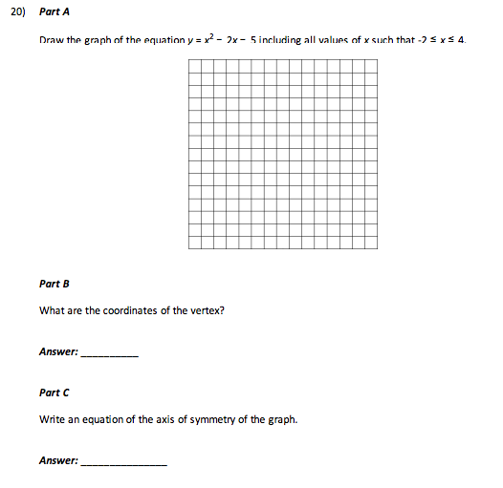
27.

- Find the roots of the equation x² + x = 8 – x graphically.

- The function p(x) includes the point (0, 5). What are the coordinates of the point after the shift of p(x) – 2?

- The function m(x) includes the point (-3, -4). What are the coordinates of the point after the shift of m(x + 4)?

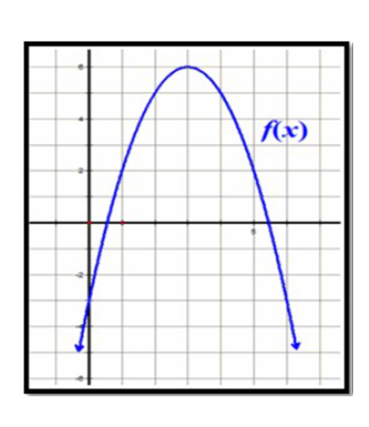
- Alicia and Brent were comparing the vertex of two quadratic functions. Brent stated that f(x) and g(x) have different maximum values. Alicia thinks that both functions have a maximum of 6. Is either of them correct? Justify your answer.

g(x) = –x² + 3x + 4

- Rewrite the equation y = x² – 8x – 2 in vertex form by completing the square. Then identify the vertex of the parabola.

- The path of a rocket fired during a fireworks display is given by the equation h(t) = 64t – 16t², where t is the time, in seconds, and h(t) is its height, in feet.

(a) What is the maximum height, in feet, the rocket will reach? [only an algebraic solution will be accepted]

(b) How many seconds will it take the rocket to hit the ground? [only an algebraic solution will be accepted]

- Solve the following system of equations algebraically:
y = x² – 6x + 9
y = –9x + 19

- Let f(x) = x² + 4x – 5 and g(x) = 2x + 3. On the set of axes below, draw the graphs of y = f(x) and y = g(x). Using this graph, determine and state all coordinates for which f(x) = g(x).
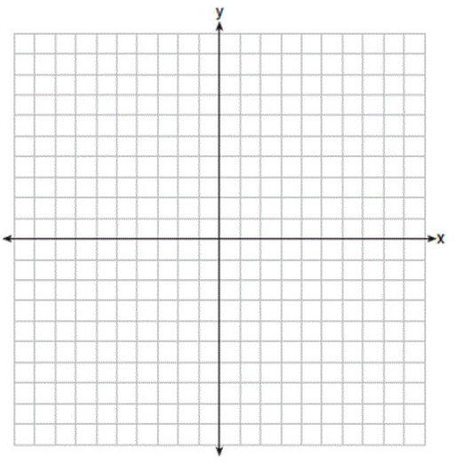

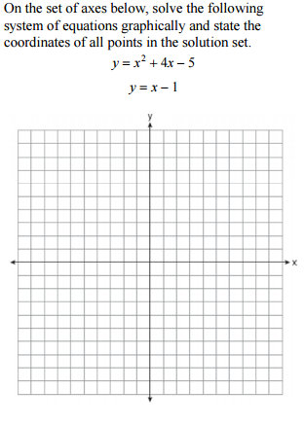
36.
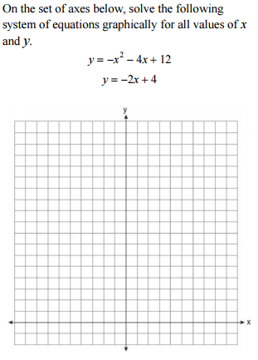
37.

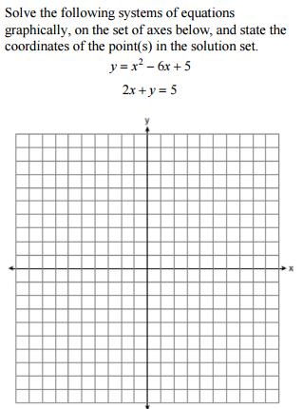
38.

39. Solve and check the following system
y = $2x +3$
y = $x^{2} x+ 1$

40. Solve and check the following system
y = $3x-6$
y = $x^{2}-x-6$

