- C
- A
- A

- C
- A
- A

- A

- (-4, 0) & (2, 0)
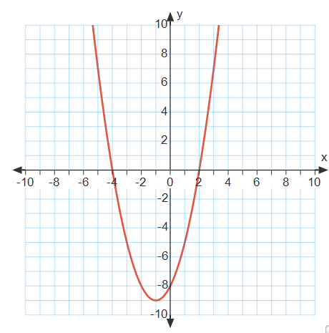

- (0, 3)

- (-7, -4)

- They have different values. f(x) has a maximum of 6 and g(x) has a maximum of 6.25

- y = (x – 4)² – 18 Vertex (4, -18)

- A) Maximum 64 feet
B) 2 seconds

- (-5, 64) & (2, 1)

- x = -4 & 2
