Name : Date:
Midterm Review 3.5
- If you invest $40 in an account for 10 years at a 3% interest rate how much money will you have?

- If you invest $2040 in an account with 5% interest rate for 15 years how much money will you have?

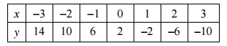
- Identify the following as linear or exponential functions and write their equations.

Linear or Exponential? y =

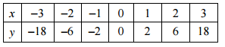

Linear or Exponential? y =

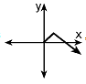
- If the graph of f(x) is , which of the following is the graph of f(x) +1?

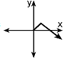

- If the graph of f(x) is , which of the following is the graph of f(x-1)?

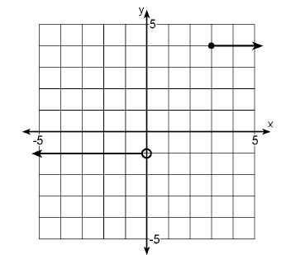
- Which of the following describes the graph shown?

Answer Key
- $53.76
- $4241.01
- Linear y = -4x + 2
- A
- D
- B

Answer Key
- $53.76
- $4241.01
- Linear y = -4x + 2
- A
- D
- B

Answer Key
- $53.76
- $4241.01
- Linear y = -4x + 2
- A
- D
- B

Answer Key
- $53.76
- $4241.01
- Linear y = -4x + 2
- A
- D
- B

Answer Key
1) $53.76
2) $4241.01
3) Linear y = -4x + 2
4) A
5) D
6) B

Answer Key
1) $53.76
2) $4241.01
3) Linear y = -4x + 2
4) A
5) D
6) B

Answer Key
1) $53.76
2) $4241.01
3) Linear y = -4x + 2
4) A
5) D
6) B

Answer Key
1) $53.76
2) $4241.01
3) Linear y = -4x + 2
4) A
5) D
6) B

