Name_________________ Date______________
Math 8

Graphing Equations Using a Table Homework

Construct a Table of the Equation and Graph

- y = 3x – 4

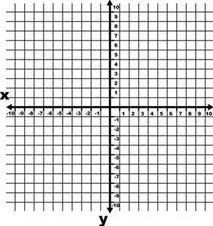
- y = -4x + 2
- y = x – 8

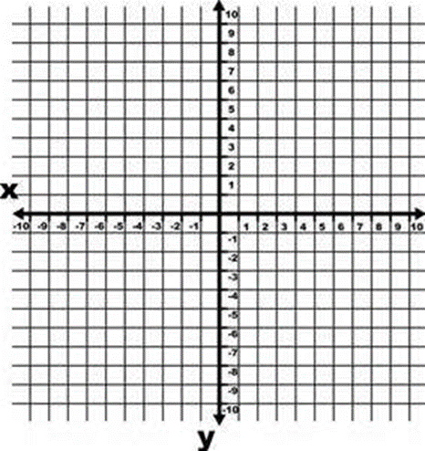

- y = -5x

