Name: _______________________________ Date: ___________________

Kobrin/Losquadro Math 8

**Final Exam Review # 3 – Transformations**

**1.** Point *N*’(-3, 1) is the image of point *N*(3, -1). Which of the following transformations occurred?

**A.** Point *N* was reflected over the *x*-axis.

**B.** Point *N* was reflected over the *y*-axis.

**C.** Point *N* was translated six units up and two units left.

**D.** Point *N* was translated two units up and six units left.

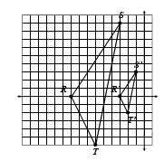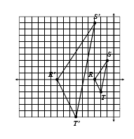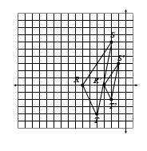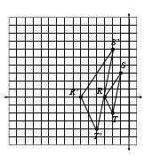

**2.** Which graph shows a dilation with scale factor of 1/3?

**A.**

**B.**

**C.**

**D.**

***K***

***N***

***D***

64°

55°

***S***

***P***

***H***

28 m

26 m

29 m

**3. If Δ*KND* ≅ Δ*SPH*, which correctly gives the   
 measure of ∠*H* and the length of *KN*?**

**A.** *m***∠***H* = 64°; *KN* = 29 m

**B.** *m***∠***H* = 61°; *KN* = 29 m   
**C.** *m***∠***H* = 64°; *KN* = 28 m   
**D.** *m***∠***H* = 61°; *KN* = 28 m

**4. If Δ*LMN* with vertices *L*(-7, -2), *M*(-1, -5),   
 and *N*(-6, -8) is reflected along the *y*-axis,   
 what will be the coordinates of *L*’*M*’*N*’?**

**A.** *L*’(-7, 2), *M*’(-1, 5), *N*’(-6, 8)

**B.** *L*’(7, -2), *M*’(1, -5), *N*’(6, -8)

**C.** *L*’(7, 2), *M*’(1, 5), *N*’(6, 8)

**D.** *L*’(-2, -7), *M*’(-5, -1), *N*’(-8, -6)

**6. Which pair of points represent a 180°   
 degree rotation around the origin?**

**A.** *A*’(2, 6) and *A*’(-6, -2)

**B.** *B*’(-1, -3) and *B*’(3, -1)

**C.** *C*’(-4, -5) and *C*’(-5, 4)

**D.** *D*’(7, -2) and *D*’(-7, 2)



**5. Trapezoid *ABCD* is shown below. Which   
 transformation will result in an image that  
 lies completely within the first quadrant?   
 Check all that apply. Assume all rotations   
 are about the origin.**

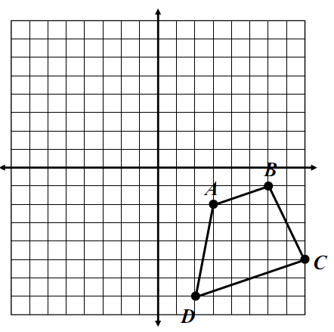

A reflection in the *x*-axis.

A reflection in the *y*-axis.

A 90° counterclockwise rotation.

A 180° rotation.

A 270° clockwise rotation.

Translation along the rule   
(*x*, *y*) → (*x* – 1, *y* + 9).

**7. If Δ*WXY* with vertices *W*(4, 2), *X*(6, 10),   
 and *Y*(8, 4) is dilated using a scale factor   
 of 2, what will be the coordinates of *W*’*X*’*Y*’?**

**A.** *W*’(2, 1), *X*’(3, 5), *Y*’(4, 2)

**B.** *W*’(6, 4), *X*’(8, 12), *Y*’(10, 6)

**C.** *W*’(8, 4), *X*’(12, 20), *Y*’(16, 8)

**D.** *W*’(8, 2), *X*’(16, 10), *Y*’(16, 4)

**8. Identify the scale factor that was used to   
 graph Δ*F*’*G*’*H*.**

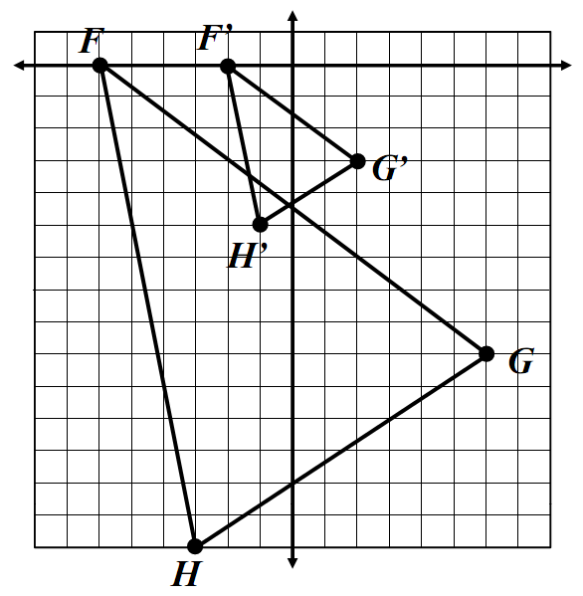

**A.** 3

**B.** 4

**C.**

**D.**



**9.** Complete the congruency statement below.

*M*

*C*

*R*

53°

60°

15 cm

16 cm

14 cm

*F*

*T*

*K*

53°

67°

15 cm

16 cm

14 cm

**Δ***MCR* ≅

**10.** If quadrilateral *ABCD* ≅ quadrilateral *GFED*,   
 find each measure.

65°

142°

*A*

*C*

*D*

*E*

*F*

*G*

74°

7 in

5 in

12 in

9 in

*m*∠*F* =

*EF* =

*B*

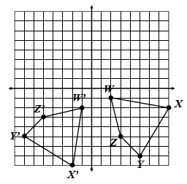

**13.**

**A.** Reflection; *x*-axis **B.** Reflection; *y*-axis  
**C.** Rotation; 90° counterclockwise **D.** Rotation; 270° counterclockwise



**11. Which triangles show a translation of the   
 shaded triangle? Check all that apply.**

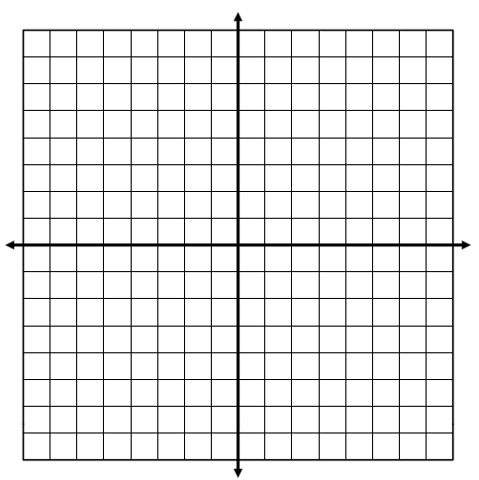

**A**

**B**

**C**

Triangle A

Triangle B

Triangle C

**12. The coordinates of Δ*TUV* and its image   
 after a transformation are given below.   
 Identify the transformation.**

**14.**

**A.** Translation; (*x*, *y*) → (*x* – 8, *y* – 9) **B.** Translation; (*x*, *y*) → (*x* – 9, *y* – 8)  
**C.** Rotation; 180° counterclockwise **D.** Reflection; *y*-axis

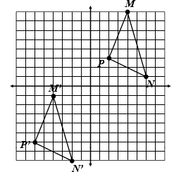

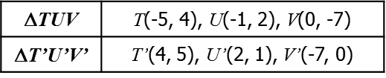

**A.** A reflection in the *x*-axis. **B.** A reflection in the *y*-axis.

**C.** A 90° counterclockwise rotation   
 about the origin.

**D.** A 90° clockwise rotation about   
 the origin.

**Graph and label each figure and its image under the given transformation(s). Then, give the new coordinates.**

**15.** Rectangle *ABCD* with vertices *A*(2, 8), *B*(8, 6),   
 *C*(7, 3), and *D*(1, 5); reflection in the *x*-axis.

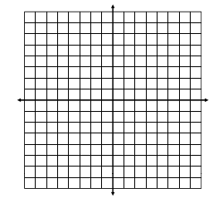

***A’*:**

***B’*:**

***C’*:**

***D’*:**



**17.** Quadrilateral *JKLM* with vertices *J*(-4, -1),   
 *K*(-1, -2), *L*(0, -5), and *M*(-7, -8); 180° rotation

***J’*:**

***K’*:**

***L’*:**

***M’*:**

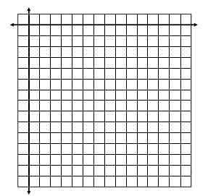

**18.** Triangle *TUV* with vertices *T*(4, 0), *U*(6, -4),   
 and *V*(2, -6); dilation with scale factor *k* = 

***T’*:**

***U’*:**

***V’*:**



**16.** Trapezoid *PQRS* with vertices *P*(-7, 7), *Q*(-1, 6),   
 *R*(0, 4), and *S*(-4, 1); translated along the rule   
 (*x*, *y*) → (*x* + 3, *y* – 7)

***P’*:**

***Q’*:**

***R’*:**

***S’*:**