Name: ______________________________ Date: _____________

Teacher: ____________________________ CC Algebra

Cumulative Review #2.6

Show work for all questions for full credit
& write your answers on the lines provided!!!
(If you feel no work is needed you must explain your reasoning.)

1. What is the difference when 3x² – x – 2 is subtracted from 6x² + 4x – 5?

A. 9x² + 5x + 14

B. 9x² + 5x – 7

C. 3x² + 5x – 3

D. 3x² + 5x – 7

1. ______________________

2. Which point lies on the boundary line of the graph of the inequality 3y + 4x < 12?

A. (−3, 0)

B. (8, 2)

C. (0, 3)

D. (3, 0)

2. ___________________

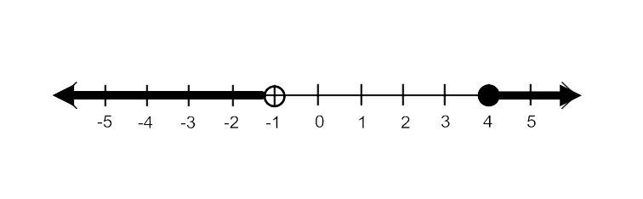
3. For the following graph, write a compound inequality that describes all of the numbers
shown on the graph.

3. ___________________

4. Given f(x) = 4x - 3 and g(x) = x² + 2x + 1, find f(2) + g(–2).

5. David has two jobs. He earns $8 per hour babysitting his neighbor’s children and he earns
$11 per hour working at the coffee shop.

- Write an inequality to represent the number of hours, x, babysitting and the number of hours, y, working at the coffee shop that David will need to work to earn a minimum of $200.

5a. _________________

- David worked 15 hours at the coffee shop. Use the inequality to find the number of full
hours he must babysit to reach his goal of $200.

5b. __________________

