Name: ______________________________ Date: _____________

Teacher: ____________________________ CC Algebra

Cumulative Review #2.2

**Show work for all questions for full credit**

**& write your answers on the lines provided!!!**

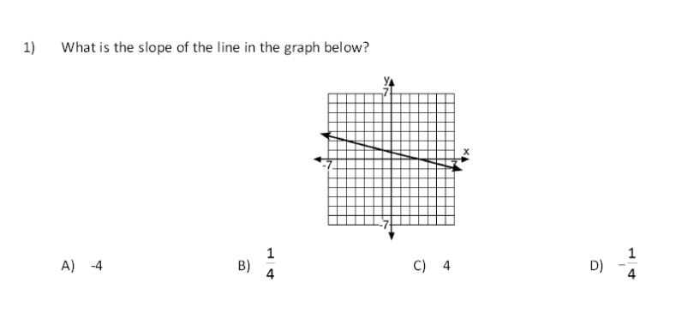(*If you feel no work is needed you must explain your reasoning.)*

1. _____________

2. The length of a side of a square is described by the expression 4x – 8. What is the perimeter of this square in terms of x?

A. P = 8x − 16

B. P = x − 2

C. P = 16x2 – 64x + 64

D. P = 16x – 32

2. _______________

3. Given − x −  ≥ 7x + 3, which property is used below?

3(− x − ) $≥$ 3(7x + 3)

A. Distributive Property

B. Multiplication Property of Inequality

C. Subtraction Property of Inequality

D. Associative Property of Multiplication

3. _______________

4. Which system of equations has no solution?

A. y = 4x – 9 and y + 4x = 3

B. y = 2x and 2y = x – 9

C. y + x = 0 and y = x

D. y = 3x + 7 and y – 3x = −2

4. _______________

5. Is the point (−4, −5) on the graph of the line whose equation is y – 2x = 6?

5. _______________

6. The Acme Concrete Company needs to deliver 15c2 + 8c − 24 cubic yards of concrete to a particular client in a single day. So far they have delivered 12c2 – 16c + 38 cubic yards. How many more cubic yards (in terms of c) must be delivered to fulfill their client’s order?

6. _______________

7. Six times a number decreased by seven is the same as four times the number increased by three. What is the number? [Only an algebraic solution will be accepted.]

7. _______________

8. Simplify: (−3x4y5)4

8. _______________

9. Solve the following system of equations algebraically and check your answer.

5x + y = 15

3x + y = 11

9. _______________

10. The perimeter of a rectangular garden is 320 yards. If the length is 8 yards less than 3 times the width, what are the dimensions of the garden? *[Only an algebraic solution will be accepted.]*

10. ________________