Name: ______________________________ Date: _____________

Teacher: ____________________________ CC Algebra

Cumulative Review #1.5

**Show work for all questions for full credit**

**& write your answers on the lines provided!!!**

(*If you feel no work is needed you must explain your reasoning.)*

1. Which inequality is equivalent to 4 − 4x > 16?

A. x > −3

B. x > 3

C. x < −3

D. x < 3

1. ___________

2. A ride in a taxi costs $3.50 plus $0.35 for every mile traveled. If Sam travels x miles, then which of the following algebraic expressions represents the cost of the trip?

A. $3.50 + $1.40x

B. $3.50 + $0.35x

C. $3.85x

D. $0.35 + $3.50x

2. ___________

3. The statement “the sum of twice a number and 18 is greater than 25” can be expressed as

1. 2n + 18 = 25 C. 2(n + 18) < 25
2. 2(n + 18) > 25 D. 2n + 18 > 25

3. __________

4. It costs $75 per hour plus a $65 service fee to have a home theater system set up for you. Let *t* represent the number of hours. Which expression represents the total cost?

A. 75*t* + 65 C. 140*t*

B. 65*t* + 75 D. 75*t*

4. __________

5. Simplify the following expression express your answer in standard form :

t3 + t4 – 1(t2 – t) + t2 + t – t

5. ______________________

6. Solve and write the solution in interval notation of the following inequality.

7w − 3(6 + 2w) ≤ 3(w − 8)

6. ____ ____

7. When Bella emptied her wallet, she had 14 coins, all quarters, dimes, and nickels. She had twice as many dimes as quarters and twice as many nickels as dimes. All together, the value of the coins was $1.30. How many of each coin did she have?

[*Only an algebraic solution will be accepted.*]

7. __________

8. A family has an income of $2,340 each month. The family spends  of its income each month on housing. How much of the family’s income (in dollars) remains after spending  of it on housing?

8. __________

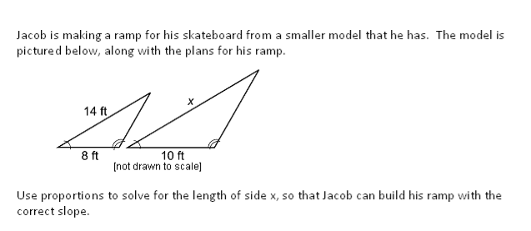9.

9. __________

10. Solve and check.

8a − 3(5 + 2a) = 85 − 3a

10. __________