Name: ____________________________________ ANSWER SHEET:January 2016
Common Core Algebra

Part I
 | 1. |  | 2.
 | 3. |  | 4.
 | 5. |  | 6.
 | 7. |  | 8.
 | 9. |  | 10.
 | 11. |  | 12.
 | 13. |  | 14.
 | 15. |  | 16.
 | 17. |  | 18.
 | 19. |  | 20.
 | 21. |  | 22.
 | 23. |  | 24.

25.  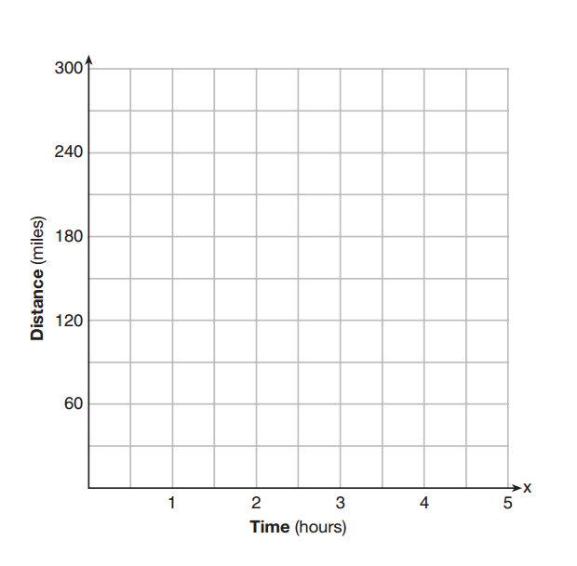 | 26.
27. | 28.
29. | 30.
31. | 32.

33. | 34.
35. | 37.  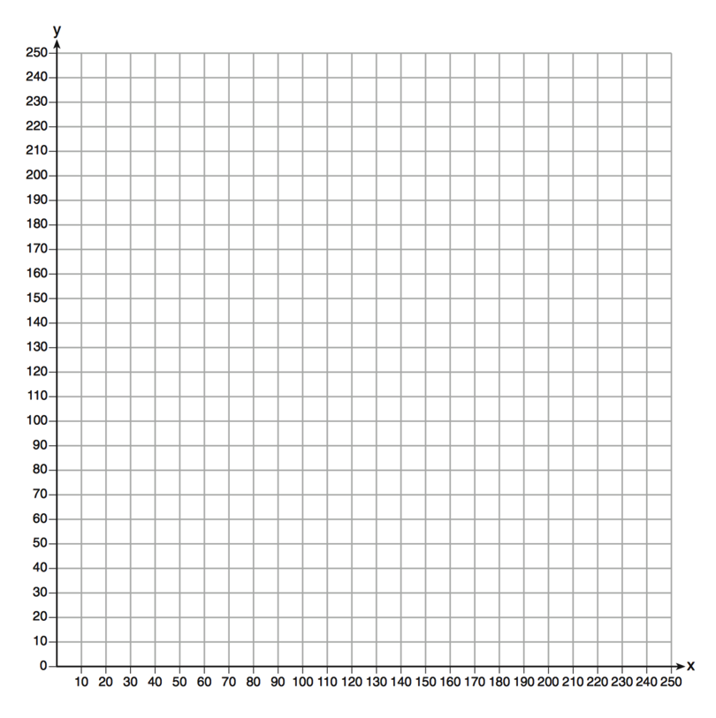
36.

