Name: _________________________________________________ April 30, 2018
Kobrin/Losquadro Math 8

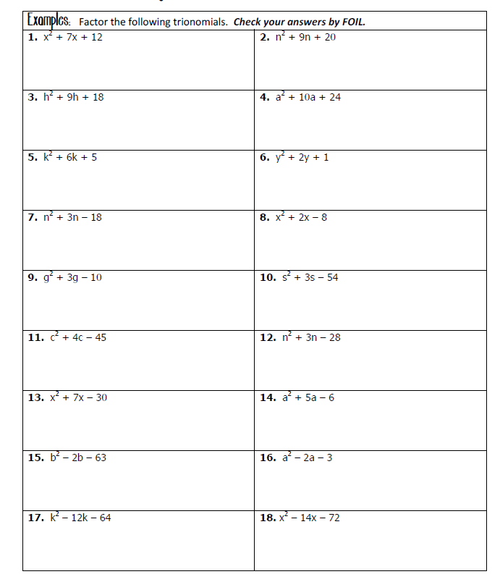
Factoring Trinomial Practice

