Name: _________________________________________ Date: ______________________
CC Algebra

Quadratic Equations Word Problems – Classwork

1. A homeowner wants to increase the size of a rectangular deck that now measures 15 feet by 20 feet, but building codes states that you cannot have a deck larger than 900 square feet. If the length and width are to be increased by the same amount, find, to the nearest tenth the maximum number of feet that the length of the deck may be increased in size legally.
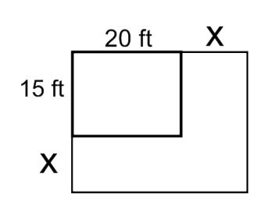

2. A rectangular garden measuring 12 meters by 16 meters is to have a walkway installed around it with a width of x meters, as shown in the diagram below. Together, the walkway and garden have an area of 396 square meters.
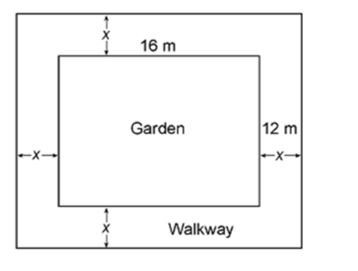
Part A
Write an equation that can be used to find x, the width of the walkway.

Part B
Describe how your equation from Part A models the situation

Part C
Using your answer from Part A, Determine and state the width of the walkway, in meters. Show your work.

Name: _________________________________________ Date: ______________________
CC Algebra

Quadratic Equations Word Problems – Homework

3. Jacob wishes to pave a pathway, w meters wide, that will surround a garden measuring 12 meters by 16 meters. The pathway will increase the total area to 285 square meters. How wide is Jacob’s pathway?

4. A plot of land for sale has a length that is 8 feet less than the width. A farmer will only purchase the land if its area measures 240 square feet. Which dimensions will allow the farmer to purchase the plot of land?

5. A park is undergoing renovations to its gardens. One garden that was originally a square is being adjusted so that one side is doubled in length, while the other side is decreased by three meters.
Part A
The new rectangular garden will have an area that is 112 more than the original square garden. Write an equation that could be used to determine the length of a side of the original square garden.

Part B
Determine the area, in square meters, of the new rectangular garden.

